*******************^+^Ao

Pn0?'4 H,£*mP CML 12/99 PO Bok 47070

Atlanta GA 30362-0070

DIGIT 303



**r J/wly** 24**-**3(1 **Las Vegas, NV**

^/ww.aloa.’org

1G1JF14TOR7100027

No, this isn’t an eye exam.  
It’s a MN code.

And with the new Mitchell  
YIN Interpretation Guide, it’s your key to  
correctly ordering a replacement key or

locking mechanism.

1999 Mitchell "

Automotive VIN Interpietation

**Alitche//**



•The first guide of its kind - interpreting the VIN code  
enables you to have the correct tools for every  
lockout job you’re asked to perform.

* Published once every year for the most updated  
  information you can get.
* Asked for by locksmiths and written for locksmiths.
* Special introductory price of only $35 - it’s regularly  
  $49 - that’s a savings of almost 30%!

“What I find useful about the book is that it lets me verify that when I go  
out to work on a vehicle, I have the right tools and equipment to do  
the job. Up until now, there really hasn’t been anything available to the  
locksmith industry to provide this information, and it’s all conveniently  
located in one book. ”

- Keith Smith

Aquarius Lock & Key, Denver, Colorado

Call today and receive this VIN interpretation guide for a special introductory price - $35 (that’s a 30% savings!)

1 800 238-9111,

ext. 8508

Mitche//

Contents

Features

4

President’s Journey

By John J. Greenan, CML, CPS

**Qotnhftr**



**14**

The Locksmith Industty Advisory Committee...What it is.

A group dedicated to preserving ethics and good will through the security industry. Learn more about this organization and how it functions.

By Mike Emery

**16**

All Aboard!

Keynotes catches up with Tech Train’s Steve Young for a conversation on the future of auto security.

By Don Dennis, CPL

**19**

Lock Manufacturing

Australia’s oldest lock maker is profiled.

By Michael A. Ferrill

22

Determinator, i’ll be back...with your car keys!

A new twist on an old concept.

No futuristic technology (or robots) here—just car keys in a flash!

By Sal Dulcamara, CML

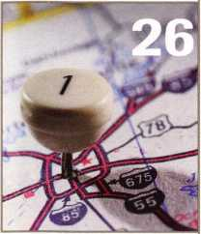

**26**

A Guide for the Casual Automotive Locksmith So, you think you need to spend $10,000 on new equipment or get out of the business entirely? Think again!

By Sal Dulcamara, CML

**30**

Locksmith Librarian

This month, our book critic looks at Robert Arthur’s GM Steering Column Repair: A Guide for the Locksmith.

By Michael A. Ferrill

**32**

Mastering Your Job Search

Looking for a job is harder than it seems even when you’re a capable locksmith. Take control of your job hunt with this valuable article.

By Claire Cohen, CML

**41**

The Cover

This issue’s assembly of articles on automotive security will help locksmiths keep on the right road for products and information.

Legislative Update

Victory comes at a price.

By Tim McMullen

Art direction/design Valerie Rowe



Keynotes

October 1999

**Volume 45, Issue 9**

**Departments**

6

Core

Insulgard heads to Columbia! Plus, a prolific  
Keynotes author and longtime ALOA member  
passes away.

8

Upcoming Events

10

Security Marketplace

42

Authors in this issue

44

Back Page

This month will mark the first ever Professional Locksmith Day in South Carolina!

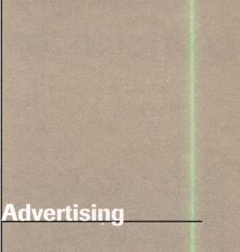

36

Associate Members

34

Classifieds

42

Ad index

: :

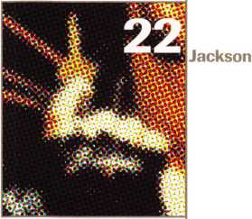

Communications/Financial Coordinator Editorial Advisor

Advertising Sales

Contributing Editors

Contributing Authors

[david@aloa.ioffice.com](mailto:david@aloa.ioffice.com)

Patanya Johnson

John D. Cannon, CML

[jdcannon@worldnet.att.net](mailto:jdcannon@worldnet.att.net)

Marvin Diamond

Native American Journal Co.

(770) 998-7056

[thediamonds@mindspring.com](mailto:thediamonds@mindspring.com)

Paul Chandler, CRL

Claire Cohen, CML

Sal Dulcamaro, CML

Jerome V. Andrews, CML

Brian Costley, CML, CMS

Bob De Weese, CPL

Ray D’Adamo, CML

Michael A. Ferrill

James Glazier, CML

Daniel Graffeo, CRL, CMS

Wayne Gurnee, CRL

A.J. Hoffman, CML

Ken Holmlund, CRL

Ray Lusk, CML

Mark Ohno

Randy Simpson, CML

Robert Stafford, CPL

Dave Thielen, CML

Additional contact information for die ALOA Board and most Keynotes authors is available through “Locksmith Search'" on the ALOA website- [www.aloa.org](http://www.aloa.org) or by contacting the ALOA office at 3003 Live Oak Street; Dallas, TX 75204; [800)532-2562;

FAX [214)827-1810; e-mail [aloa@aloa.org](mailto:aloa@aloa.org).

President

John J. Greenan, CML, CPS (773) 486-2030

Secretaiy

John D. Cannon, CML (703) 960-6413

Directors, Northeast

James H. Glazier, CML (301) 831-5454 John C. Magee, III

1. 845-3434 William L. Young, CML
2. ) 647-5042

Directors, Southeast

Thomas W. Tate (850) 476-4211 Donald E. Rul6, CML (601) 324-2658

Directors, North Central

Mark E. Blum, CML, CPS (517) 482-5809 Tom Ripp, CRL (608) 262-3831

Director, South Central

Randy L. Simpson, CML (713) 780-7026

ALOA Professional Staff

|  |  |  |
| --- | --- | --- |
| Executive Director | Charles W. Gibson, Jr., CAE [charlie@aloa.ioffice.com](mailto:charlie@aloa.ioffice.com) |  |
| Operations Manager | Mary May  [mary@aloa.ioffice.com](mailto:mary@aloa.ioffice.com) |  |
| Comptroller | Kathy J. Romo |  |
| Meetings Manager | Jessica Smith [jessica@aloa.ioffice.com](mailto:jessica@aloa.ioffice.com) |  |
| Meetings Assistant | Amy Sheffield |  |
| Government Affairs Manager | Tim McMullen [tim@aloa.ioffice.com](mailto:tim@aloa.ioffice.com) |  |
| PRP/Education Manager | David Lowell, CML, CMS [david@aloa.ioffice.com](mailto:david@aloa.ioffice.com) |  |
| PRP/Education Coordinator | Ashley Spencer |  |
| Membership Manager  Chapters & Regional | Brandon Durrett  [brandon@aloa.ioffice.com](mailto:brandon@aloa.ioffice.com) |  |
| Associations Liaison | Tim McMullen |  |
|  | [tim@aloa.ioffice.com](mailto:tim@aloa.ioffice.com) |  |
| Information Systems Manager | Randy McChristian | JjLtAi |
| Mailroom Assistant | Mike Harrison | w |

Directors, Southwest

Gordon R. Racine, CML (719) 384-4707 John A. Ilk, CRL (602) 420-2174

Director, Northwest

Scott L. Henke, CRL, CPS (907) 248-3785

Director, Associate Members

Judd Penske (800) 634-5465

Trustees

Dallas Brooks

(334) 826-8990

David M. Lowell, CML, CMS

(800) 532-2562

Breck H. Camp, CML

(770) 455-6244

Edwin Toepfer, RL

(416) 225-5589

Chairmen of International Affairs

Laurence P. Mills/Australia (129) 958-0445 Hans Mejlshede, CMlVEurope FAX (453) 139-1004

Mission Statement: The Associated Locksmiths of America, Inc. is dedicated to enhancing the professionalism, education and ethics among locksmiths and those in related sectors of the physical security industry. With approximately 10,000 members in the United States, Canada and the freeworld, ALOA is poised to help members obtain the knowledge, the strength, and the confidence to perform their role in the physical security field with pride and dignity. But it is only through active involvement and participation that ALOA can fully achieve its potential-and can help members to achieve theirs.

Policies: Keynoted is the official publication of the Associated Locksmiths of America, Inc. (ALOA). Keynoted acts as a moderator without approving, disapproving, or guaranteeing the validity or accuracy of any data, claim, or opinion appearing under a byline or obtained or quoted from an acknowledged source. The opinions expressed by the authors do not necessarily reflect the official views of ALOA. Also, appearance of advertisements and new products or service information does not constitute an endorsement of products or services featured by the Association. The Association does not accept responsibility for the inaccuracy of any data, claim, or opinion appearing in this publication, due to typographical errors on the part of the authors, Association staff or its agents. Editor’s Note: This publication is designed to provide accurate and authoritative information in regard to the subject matter covered. It is provided and disseminated with the understanding that the publisher is not engaged in rendering legal or other professional services. If legal advice and other expert assistance is required, the services of a competent professional should be sought.

Authors’ Payment: Payment for eligible submissions to Keynotes will be based on the following criteria: topic, time spent and past contributions. Authors who regularly submit to Keynotes are generally paid a higher rate. The latter is especially true of authors who write to fit specific editorial needs and submit said copy by Keynotes deadlines. As a general guideline: Average payment for a 750 word, business or ‘light’ technical article would be $200. Payment for a 1500 word article involving significantly higher time and research efforts would be $400.

Payment will not be offered for articles submitted by ALOA employees or members of the ALOA Board of Directors (unless material is of a technical nature), nor for articles submitted by a company that promote that company’s products or services. ALOA reserves the right not to pay for articles submitted by an individuals) that promote a particular company’s products or services.

Disclaimer: The Associated Locksmiths of America, Inc., (ALOA), reserves the right to refuse any article for any reason. Additionally, ALOA reserves the right to edit amend or modify any article submitted for publication in order to preserve technical accuracy, clarity, fairness or grammatical correctness. ALOA will make the best efforts to notify the author of any changes. The extent of ALOA’s liability for any article or information contained therein will be a notice of correction or retraction in the next possible issue.

Keynotes® (ISSN 0277 0792) is published monthly except for the combined June/July issue by The Associated Locksmiths of America, Inc., 3003 Live Oak St., Dallas, TX 75204-6186. Telephone: (214) 827-1701; FAX (214) 827-1810: e-mail [aloa@aloa.org](mailto:aloa@aloa.org). Subscription rates for members-$15.00 per year. Second class postage paid at Dallas, Texas. POSTMASTER: Send address changes to: Keynotes, 3003 Live Oak St., Dallas, TX 75204-6186. © Copyright 1999, All rights reserved. No part of the contents may be reproduced or reprinted in any form without prior written permission of the publisher.

Past Presidents

1997-1999 Dallas C. Brooks 1995-1997 David Lowell, CML, CMS 1993-1995 Breck Camp, CML 1991-1993 Henry Printz, CML 1989-1991 Evelyn Wersonick, CML, CPS 1987-1989 Leonard Passarello, CPL 1985-1987 Joe Jackman, CML 1983-1985 Stanley Haney, CPL 1981-1983 Louis LaGreco, CPL 1979-1981 John Kerr, RL 1977-1979 Clifford Cox, CM L 1974-1977 Charles Hetherington 1972-1974 Gene Laughridge 1970-1972 William Dutcher, RL 1968-1970 Constant Maffrey, RL 1966-1968 Harold Edelstein, RL 1964-1966 William Meacham 1962-1964 Robert Rackliffe, CPL 1960-1962 Edwin Toepfer, RL 1956-1960 Ernest Johannesen

October 1999

Keynotes 1±

with .John J. Greenan

L



4

As many of you know, the Greater Philadelphia Locksmith Association Convention was regrettably canceled last month. It’s truly a shame that the severe weather shut things down. I, for one, was extremely disappointed and was looking forward to the show on this great organization’s 50th anniversary.

To those who were involved in coordinating this event, I salute your efforts.

And to the numerous members and supporters of GPLA, I applaud your dedication. It’s rare that a show like this gets canceled due to the weather, but let’s just look forward to next year’s convention and another 50 years (if not many more) of GPLA.

In this column, I would also like to welcome all new ALOA Board Members and say that I am looking forward to working with them in the future. Although so much has progressed within our association, I know there’s still more work to be done and am eager to hear the exchange of ideas from our newly appointed officers and directors.

Speaking of the ALOA Board, let me remind all members that next month is our Fall Board Meeting at the Yankee Security Convention in Sturbridge, Mass, November 5—7.1 certainly hope everyone can attend. This is a great chance for you, the members to learn more about ALOA and how it operates.

If you cannot attend the meeting, then I strongly encourage everyone to write or call their regional directors in reference to issues they feel strongly about. Your feedback is imperative to ALOA’s progress and its success as an association.

Recently, I had the pleasure of representing ALOA at the National Burglar and Fire Alarm Association convention. Overall, it was a good time, productive and quite interesting. Then again, it is always good to exchange ideas with fellow security professionals and learn of goings on in technology, legislature and other areas.

Through learning and listening, we can all stay on top of the ever changing world of locksmithing. Likewise, we can also make ALOA a stronger association now and for the future!



Keynotes

October 1999

175 101 93 _ 66_ 65_ 64 . 62 _ 51_ 48 _ 40 _ 38 . 37_ 33, 32 _ 31_ 31_ 30 _ 29 _ 26 _ 24_ 24 _ 24 _ 24_ 24 _ 23 _ 23_ 23 _ 23_ 22 _ 22 _ 21_ 21 _ 21 _ 21 _ 21 _ 20_ 20_ 19 _ 18 _ 18_

18

18_ 18_ 17 _ 17 _ 17_ 17 _ 16_ 16 _ 16 _



The Brightest

And The Best.

Kwok-kei Leung

Toshihiro Asano

Henry Raymond

Stewart Levine, CML

Charles Robertson, CML

Mary Ohmit, CPL

Yuriko Yanai

Jack Hobin, CPL

Allen Konrath

_Salvatore Dulcamaro, CML

Myeong-Rae Cho

William Neff, CML 16

David Lowell, CML 15

.Thomas Freehling, CML 15

Dana Barnum, CML 15

John Heckman, CML 15

Jeanne Lodge, CML 15.

Barry Leas, CRL 15

J. Thomas Hood, CML 15

Lawrence F. Smith, Jr., CML 14

Danny Rudd, CPL 14

John Elliott, CML 14

Larry Warnick, CML 14.

Roy Renderer, CML 14

James Watt, CML 13

Robert Carroll, CPL 13

Robert DeWeese, CPL 13

Jim Williams, CRL 13

Diana Barnum, CRL 13

Barbara Watt 13.

Anthony Ramunno, CML 13.

Jerome Cohen, CML 13

David M A Federico 12.

Eugene Altobella 12

William Lee 12.

Charles Cole, CML 12.

_Elvis Hammerschmidt, CPL 12.

Marian Swann, CRL 12.

John Shandy, CML 12.

John Dorsey, CML 11

D Michael Lee, CPL 11.

James Fowler, CML 11.

David Harris, CML 10_

John Kerr, RL 10.

Keizo Takahashi, CRL 10

Ronald Heidzig 10

Philip Rovenolt, CPL 10_

Joseph Ferrero, CML 10

James Cawby, CML 10.

Michael Robinson, CRL 10_

.Walter Lascar, RL .Thomas Vandersteen, CML .William Grant, CRL .Gary Teams, CPL .William McElheney, CML

Robert Duman, CML

Russell Fuller, CRL

Rex Parmelee, RL

James Gruber, CRL

James Brickler, CRL

Michael Groves

Daniel Landry

Edwin W Scott

.Peter Gauthier, CPL _Frank Hartung, CML Jon Griswold, CML

Paul Souber

Richard Sievers

Joe Lee, CRL

Steven Spiwak, CRL

_Robert Rodocker, CRL _Keiryu Tsukishiro, CRL Rolando Bouza

.Lonnie McKinney, CML

John Engel, CRL

Donald Shiles

Eric Veal

.Herbert Dusenberry, CML

Raymond Lusk, CML

Robin Horsley

Thomas Demont, CML

Ernest Wright

.William Wickward, CML Lester Brodsky

.Joseph Whitaker, CPL

Dale Knowles, CPL

John Ilk, CRL

James Hawley, CRL

How can I join the President's Club?

You can earn membership in this prestigious club by recruiting just 10 new members for AL0A.

*Any AL0A member may participate.

What do I get?

When you recruit 10 members, you receive a handsome blue blazer with a President's Club crest. For each additional five members you recruit, you receive a lapel pin with gold-filled numbers, indicating your recruiting successes.

You also get the satisfaction of knowing that you are helping your association, helping your industry grow, and you are helping fellow locksmiths achieve success.

How do I get started?

Contact the AL0A office for a supply of applications (800) 532-AL0A or FAX (214) 827-1810. One President's Club credit is awarded for each new applicant. Credit is awarded only after the membership application is approved. However, the credit will apply for the period in which the application is received. Failure to identify yourself as the sponsor on the application form at the time it is submitted to AL0A for processing will forfeit any credit.

*AL0A Board of Directors not eligible for membership in the President's Club.

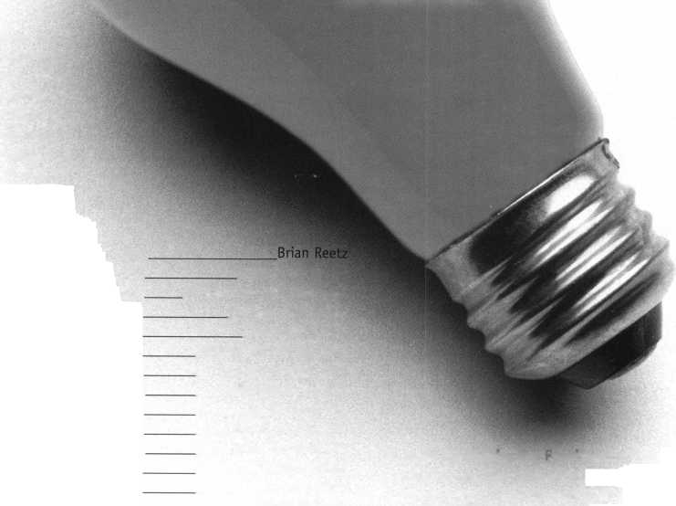

* Insulgard goes Colombian

Insulgard Corporation, a security division of Commercial Plastics and Supply Corp., recently completed a massive physical security installation at the “New Palace of Justice” in Bogota, Columbia. “They were concerned after the terrorist takeover of the old Palace of Justice in the ’80s,” says Insulgard’s Dave Stirrett, Government Project Engineer, PE. “They wanted to prevent that sort of scenario from happening again.”

For those of you who may not remember the terrorist attack, Bogota’s Ministry of Justice building was overrun by a terrorist group. Although the Colombian military forces were able to reclaim the building, several hostages were killed and the structure was torched.

Years prior to the assault, Insulgard has successfully installed security doors and windows for the Presidential Palace (Palacio Narino). This prior experience helped the company obtain the bid for the New Palace of Justice.

“We had two primary concerns,” says Stirrett. “The building itself mimics the Colonial aspects of Bogota, so there were architectural concerns that had to compliment the security concerns. The windows were designed to be bullet resistant as well as blast resistant. It also had to have very ornate architectural designs.

“It was quite challenging. The security portion was fairly routine, the architec­tural concerns were more elaborate. It’s definitely°a one of a kind design.”

* Fall Board Meeting Next Month

Mark your calendar. Next month, at the Yankee Convention in Sturbridge,

**KeynotesOctober 1999**

Mass, the ALOA Board holds its Fall Meeting. The Committee of the Whole meets November 5 and 6 and the Board meets on the 7. Members are invited to attend.

* Corbin Russwin and Intellikey form alliance

Corbin Russwin, Inc., a member of the Yale Security Group and subsidiary of Williams PLC has formed a strategic marketing alliance with Intellikey Corporation.

This alliance provides Corbin Russwin with exclusive rights to market Intellikey products through the Locksmith Wholesale and Contract Hardware Distri­bution channels that employ both Corbin Russwin and Intellikey brands.

Meanwhile, Intellikey will continue to concentrate on new product development in addition to market support of Corbin Russwin, OEM and other market segments.

* Mitchell International introduces VIN Guide for Locksmiths

Mitchell International a leader in the collision repair industry since 1946, has created a VIN Interpretation Guide specifically for the locksmith industry. Mitchell acquires the VIN interpretation information directly from the Original Equipment Manufacturers (OEMs) and is able to provide locksmiths with a compre­hensive, accurate and verified source of information. For more information visit the Mitchell web site <http://www.mitchell.com> or call (619) 578-6550.

core

#PRP

CML

Dorsey, John S. Jr., **Eau Claire, WI** Lawyer, John H., **Champaign, IL**

CPL

Cole, Thomas D-, **Albuquerque, NM** Lowe, Ryan H., **Freeport, BH** Smith, Gene J-, **Glen Ellyn, IL** Pipkin, Lewis D., **Farmington, NM**

CRL

Abaffy, S. Thomas, **Chillicothe, OH** Austin, James, **Jackson, MI** Crawford, Tony, **Knoxville, TN** Erlandson, Andrew R. Jr.,**Odessa, MO** Glispie, Vincent, **Chicago, IL** Greve, Robert, **Knoxville, TN** Jenkins, Steven, **Staumton, VA** Lockwood, William M., **Englewood, CA**

McElheney, Michael, **Toledo, OH** McGrath, Frank, **Baltimore, MD** McNeary, Jerome S., **Bridgeton, MO** Miller, Keith A., **Butler, KY** Milliorn, Rick H., **El Paso, TX** Norton, Joseph, **Cincinnati, OH** Pratt, Robert J-, **Albuquerque, NM** Ryan, William C., **Binghamton, NY** Schaefr, Paul**, Decatur, IL** Thurman, Richard, **Pegram, TN** Vigil, Victor, **Thornton, CO** Wallin, Robert, **Hampton, VA** Williams, Harold J-, **Indianapolis IN**

CPS

**Ashley, James,** Kernersville, NC

Ballotta, Peter, **Avenel, NJ** Caplinger, Charles Jr., **Woodside, DE** Carey, Bruce E., **Montrose, PA** Decker, Donald, **Fairborn, OH** Fink, Harold, **Pasadena, MD** Grist, John, **Clayton, GA**

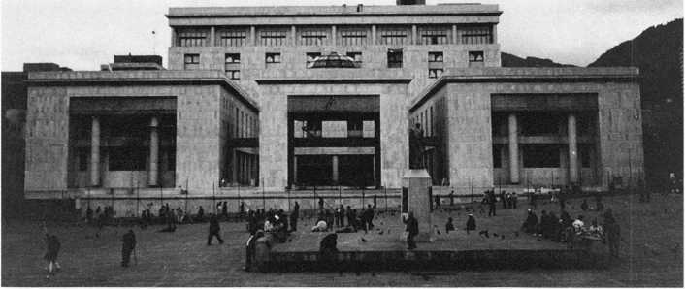

The Palace of Justice in Bogota, Columbia

Hollis, James, Gerrardstown, WV

Jenkins, Larry, Staumton, VA Jenkins, William, Louisville, KY Johnson, Dennis, Aurora, IL Rodocker, Jeremy, Fort Wayne, IN Schaefer, Paul, Decatur, IL Schubot, Ronald, Kalamazoo, MI Shermeyer, James, York, PA Weinberger, Anne, Nicholasville, KY

• Execs

Brink’s Home Security recently elected Robert B. Allen as Executive Vice President and Chief Operating Officer.

Ingersoll Rand’s board of directors has elected Brian M. McNeill as vice president of the company.

Sensormatic Electronics Corporation announced the appointment of Joseph F. Arayas as director of business develop­ment and international dealer of the company’s Access Control Division. The company also named David Jette as senior manager of technical support for the company’s Access Control Division. Other Sensormatic appointments include

Ed Boudrot as product marketing manager for the C*CURE 800/8000 line and Bob Vendetti as engineering manager of the embedded software group for the company’s Access Control Division.



• Obituaries

Keynotes is sad to say good-bye to Charles H. “Charlie” Cole. A member for over 20 years and contributing author to Keynotes, Charlie was a prolific locksmith writer. Aside from lending his expertise to the pages of this magazine, he also oversaw the Locksmith Ledger’s code hotline. He was an active member of the Mew Mexico Locksmith Association and the editor of its monthly newsletter, the NMLA Roadrunner. He was also once selected as Keynotes Advisor of the Year. Our condolences go out to Charlie’s friends and family.

SECURiTyg

LOCK COMPANY Hr

**New** Factory Replacement Parts and Locks for Security Corporation and Kumahira Safe Co. Products

* Safe Deposit Box Locks and Parts BX, KD
* Automatic Remote Tube Systems (ARTS)
* Drive Up Systems
* Vault Doors
* Night Depositories
* Camera Systems
* Key Blanks and
* Keys Cut to Code

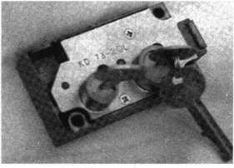

KD Series

Safe Deposit Box Locks

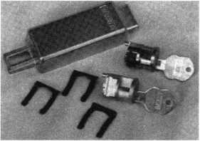

BX Series Safe Deposit Locks

1155 Chess Drive, #114 Foster City, CA 94404 Phone: (650)525-0660 Fax: (650) 525-0444

Email:

[chaslutz@securitylockco.com](mailto:chaslutz@securitylockco.com)

SECURiTyg

LOCK COMPANY BV

October 1999

Keynotes I

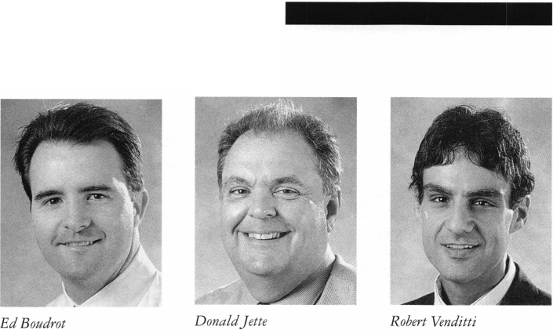

Upcoming

Events



Dept

OCTOBER

1—3

Jo-Van National Trade Show and Educational Seminar Contact: Ron Wilson (416)752-7249

2

^ ALOA PRP Sitting

Lou-Miss Locksmiths Association

Convention

Baton Rouge, LA

Contact: David Lowell, CML, CPS

(214)827-1701

(214) 827-1810 fax

3

10th Annual Locksmith Flea Market/Swap Meet Hayward, CA

SF California Locksmiths Association Contact: Blaine Lucas, CML (510)278-2583

9

**fk** ALOA PRP Sitting Dallas, TX ALOA

Contact: David Lowell, CML, CPS (800) 532-2562 (214) 827-1810 fax

9

The Lock Museum of America 27th Annual Lock Collector's Show Terryville, CT

American Lock Collector's Association Contact: Geri Stutting (203) 869-6260

10

**^** ALOA PRP Sitting Burbank, CA Clark Security Products Contact: Terri Burges (619)974-5273 (619) 974-5284 fax

14-17

POLA TradeShow ’99 Pittsburgh, PA

Penn-Ohio Locksmiths’ Association Inc. Contact: Sally Paris (216)267-2692 Martha or Jerry Eggler (216)676-8464

16-17

Professional Safe Moving Class Eau Claire WI

Indian Head Chapter of ALOA Contact: John Dorsey (715)832-4207

16-18

DHI 24th Annual Convention and

Exposition

Dallas, TX

Contact: DHI

(703) 222-2010

16

/ALOA PRP Sitting Richmond, VA

Virginia Locksmiths Association Contact: RT Earll, CML (703) 368-0595 (703) 335-0852 fax

17

ALOA PRP Sitting Largo, MD

Institutional Locksmiths Association Contact: Philip A Rovenolt (301) 645-7786 (202) 645-6530

17

ALOA PRP Sitting Coraopolis, PA Penn/Ohio Locksmith Assoc. Contact: Martha R. Eggler (216)676-8464 (216) 267-2511 fox

24

ACE Classes St. Louis, MO

Gateway Locksmiths Association Contact: Paul Skoulby (314)423-3720 (314) 423-3720 fax

29

ALOA PRP Sitting Tri-Regional Convention Richmond, BC

British Columbia Association of Professional Locksmiths Contact: James F. Brouchton (250)745-6260 (250) 745-6260 fax

29-31

Convention

Basildon, London

Master Locksmiths Association

London Region

Contact: D. Stokes

0181-520-7450

0181-521-8376 fax

[MLA_LR@hotmail.com](mailto:MLA_LR@hotmail.com)

NOVEMBER

6-10

ACE Classes ALOA PRP Sitting Fall Board Meeting

1. Yankee Security Convention Sturbridge Host Hotel Sturbridge, MA Contact: Rob Mahoney (800) 209-8266

13

ALOA PRP Sitting Dallas, TX ALOA

Contact: David Lowell, CML, CPS (800) 532-2562 (214) 827-1810 fax

20

ACE Classes Oklahoma City, OK Oklahoma Master Locksmiths Association

Contact: Lowell Roberts (405)732-5838 (405) 741-5838 fax

DECEMBER

n

**^** ALOA PRP Sitting Dallas, TX ALOA

Contact: David Lowell, CML, CPS (800) 532-2562 (214) 827-1810 fax

2000

FEBRUARY

13

ALOA PRP Sitting Houston, TX

The Texas Locksmiths Association Contact: Judy Clifford (409) 297-2413 (409)297-1483 fax

APRIL

6-9

**Cn** Ace Classes MLANJ 2000 Annual Convention Somerset, NJ (973) 267-8884 (973) 538-2248 fax [www.mlanj.org](http://www.mlanj.org)

19-23

Easter Convention Birmingham, England Master Locksmiths Assoc in the UK Contact: Mick Friend [Mick@locksmiths.co.uk](mailto:Mick@locksmiths.co.uk)

MAY

1-6

SAFETECH 2000 Birmingham, AL

(214)827-7233

JULY

24-30

ALOA 2000 Security Expo Las Vegas, NV (214) 827-1701

2001

MARCH

28-April 1

MLANJ 2001 Annual Convention Somerset, NJ (973) 267-8884 (973) 538-2248 fax [www.mlanj.org](http://www.mlanj.org)

JULY

16-22

ALOA 2001 Security Expo Baltimore, MD (800) 532-2562

2002

JULY

22-28

ALOA 2002 Security Expo Rosemont, EL (800) 532-2562

Indicates ALOA ACE Class Indicates PRP Sitting

***Keynotes***

October 1999

WE'RE BACK IN STURBRIDGE

£ % |Pf

**Yankee**

1999

**Security Conference**

**And Trade Show LOCATION: Sturbridge Host Hotel**

**Sturbridge, MA 01566 TRADE SHOW: November 6-7, 1999 CLASSES: November 8-10, 1999**

**November 6-10, 1999**

Sf Bl

n*

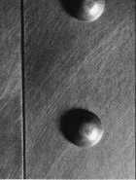

* **A.L.O.A., A.C.E. certified instructors**
* **Many new and innovative classes**
* **The industry's top manufacturers,  
  distributors and manufacturers'  
  representatives**

For more information,  
visit us on the web at

**[www.yankeeconvention.com](http://www.yankeeconvention.com)**

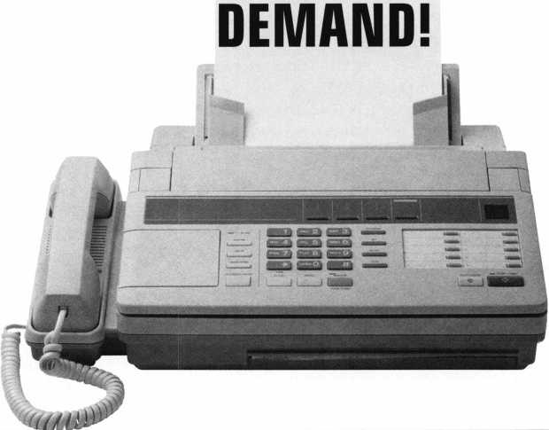

Need information in a hurry?

Just call 310.575.5074 and you will be faxed:

Your association continues to explore ways to provide you, our members, with new benefits and services.

#i

#2

#3

#4

#5

#6

#7

#8

#9

#10

#11

#12

#13

#14

#15

#16

#17

#18

A list of all documents available through this service

Becoming A Locksmith  
Locksmith Career Summary  
Locksmith School List  
ACE Class Schedule  
Certification Information  
PRP Category List  
ALOA Membership Application  
ALOA List of Benefits  
Scholarship Application Form  
ALOA Video Library Order Form  
ALDA Membership Items Order Form  
Safe & Vault Technicians Association  
Member Application/Subscription Form  
ALOA Chapter Roster  
Legislative Action Network  
Legislative Action Network Newsletters  
Various State Laws  
Industry Position Paper

October 1999

***Keynotes*** | 9



Lockmasters Inc.

The New Undercounter Wrench is available from Lockmasters. The Undercounter Wrench is a specialized wrench, which is designed to remove the nut, holds the key lock on bank teller drawers. With it’s two 90-degree bends the wrench will loosen the nut and remove the cylinder in minutes. It will work on Diebold, Mosler and LeFebure equipment.

Lockmasters has combined two safe deposit lock change keys into one tool, the Safe Deposit Change Tool. The Safe Deposit Change tool has a Lefebure 7700 Series change on one end, and Diebold 17570 change key on the other. The Diebold tool will also change the Sargent and Greenleaf4545 Series and the Ilco Unican 5400 series. Both change keys are machined from steel and the handle is anodized aluminum; which means no more broken keys.

Lockmasters 5085 Danville Road Nicbolasville, KY 40356-9531 (800) 654-0637

Ilco Unican Corp.

The Unican Lock Division of Ilco Unican announces the release of the Safe Lock 685. This three-wheel mechanical safe lock is UL listed Group 2M and is designed for applications such as installation on safes of all types up to a TL 30 rating. The model 685 replaces the model 683 in the Group 2M category. The lock division also announces the release of two safe dials. The D50 dial is the full configuration dial which replaces the former D20 dial both of which are of the top reading style for privacy while dialing combinations. The D60 dial has a smaller gripping area and like its’ bigger brother is designed to convert to a key locking dial with the addition of a key cylinder.

Unican Lock Division (800) 849-8324 (800) 346-9640

Jet Hardware Mfg. Corp.

Jet Hardware announces TKD-1 Transponder Key Detector on the current market. It simply says, “YES” or “NO,” to determine if a customer s plastic head key is or is not a Transponder. It will eliminate ruined keys and insure that the key being operated is correct, therefor eliminating damage.

Jet Hardware 800 Hinsdale Street Brooklyn, NY 11207

Security Door Controls

SDC introduces the HiTower Cylindrical Locks. The new SDC ZA7200 HiTower is an electrically operated, ANSI/BHMA Grade 1, extra heavy-duty cylindrical lock that combines life safety and security for access control applications. Features include a vandal resistant pressure release lever, lever power return spring, choice of lever handle styles and low current draw. The lock may be ordered with another manufactures keyway or prepared to accept another

**10 | KeynotesOctober 1999**

manufactures standard key cylinder or interchangeable core. A REX output is optional for access control applications. SDC ZA7200 HiTower locks exceed 800,000-cycle test, are ADA compliant and UL listed for use with fire doors.

SDC-Security Door Controls P.O. Box 6219

Westlake Village, CA 91359-6219 (805) 494-0622 (805) 494-8861 fax

Corbin Russwin

Corbin Russwin announced its patent pending quick reversible mortise lock, the ML2000. The handing of this lock can be changed without removing the lockcase cover. The simple procedure takes less than one minute to accomplish. The security of this lock is unparal­leled. As a preventive measure against possible vandalism, the lockset MUST be removed from the door to re-hand. The ML2000 has been tested and exceeds ANSI standards. The ML2000 is ideal for new applications or retrofitting of an existing Corbin Russwin ML2200 mortise lock.

Corbin Russwin Yale Security Group 1902 Airport Road Monroe, NC 28110 (800) 543-3658 (800) 447-6714

Sieveking Products Co.

Sieveking Products Co., announced the addition of the “Key- Scope” to its growing line of locksmith tools. This wafer lock reading tool incorporates features not found in any other scope. Key-Scope has a new variable intensity high output light. The longer wafer depressor allows the locksmith to read wafers in deeper keyways. There are two viewing lenses on Key-Scope. One lens is short focus, for standard keyways, the other is long focus for deeper keyways and safe work. Used together, the Key-Scope lenses ADD, to give a higher magnification, ideal for reading those hard to see impression marks. A padded hard-shell is included. Sieveking also announced changes to the Squeeze-Play hollow metal door mortising tool. The tool will mortise 90-percent of the edge seamed hollow metal doors found in residential and commercial markets. Improvements made to the automatic center punch feature will increase the depth of the punch marking. Squeeze-Play automatically locates and punches the locations of the square face bolt mounting screws. Squeeze-play will mortise 1 3/4" doors, and mark mounting locations for 2 1/4" x 1" and 2 1/4" x 1 1/8" square face bolts, eliminating the need to cut the door or use internal bridges. The mortise is made with no loss of the doors structural integrity.

Sieveking Product Co.

3437 South Bend Road Rockford, IL 61109 (815) 874-4030 (815) 874-5713 fax

Applied Wireless ID

AWID announced the release of the Sentinel-Prox MR-1824. This revolutionary proximity reader boasts a read range of 18 to 24 inches (46 to 61 cm) with dimensions of only 8 inches square and 1 inch thin. The MR-1824 can be powered by most access control panels, eliminating the need for auxiliary power supplies in most cases (Linear supply, 250mA at 5VDC, 600mA at 12VDC). The MR- 1824 outputs industry standard Wiegand (26-56 bit) in addition to simultaneous RS-232 and comes with a lifetime warranty against defects in materials and workmanship.

AWID

382 Route 59, Section 292 Mousey, NY 10952 (914) 369-8800 (914) 369-1195 fax

Welch Allyn

Welch Allyn’s Micro Imaging Devices Division introduced a new product to its Mini-Cam line of miniature surveillance cameras, the Lens Mount Mini-Cam. This new device offers the same combination of compact size (16 mm x 16mm x 4mm), sharp video imaging (330 TV lines of horizontal resolution) and low cost that has made the original Mini-Cam so popular while offering more flexibility for the installer. The camera provides four wire leads (2 for power, 2 for video), comes in either color or black & white and is currently available with a 6mm lens only, other versions will be introduced later. Ideal for OEM applications, the Lens Mount Mini-Cam can be incorporated into inspection systems for manufacturing processes, video telephones or video conferencing systems. Other applications include use in surveillance and covert security solutions.

WelchAllyn Inc.

4619 Jordan Road Skaneateles Falls, NY 13153-0187 (877) 576-5643 (315) 685-2854 fax

Marks USA

Marks USA introduces two key in lever Survivor Series, Grade 2 locksets featuring the “CLUTCH” which are available for both conventional and IC cores. When locked, the “CLUTCH” disengages the outside lever allowing it to turn freely. These locksets survive where rigid levers fail. Each Survivor Series rose contains its own proprietary high-strength lever support spring which eliminates lever droop. Marks USA locksets feature a lifetime mechanical warranty.

All standard functions are available in both the American with angular return and the Crescent with a smooth rounded lever.

Marks U.S.A.

5300 New Horizons Bird.

Amityville, NY 11701 (516) 225-5400 (516)225-6136

Schwab Corp.

Schwab introduced a 20" Hero file, a fire-protective file. The Hero holds up to 15 inches of letter-sized or 12 inches of legal-sized documents in each drawer. The addition of a Schwab Media Cooler, which fits in either drawer, diversifies storage to include the fire- protection required for sensitive computer media. Insulite a chemically dry insulation well known for its efficiency, provides the Hero with UL Class 350-1 Hr. fire protection. Framed by the Hero’s seamless steel body, Insulite is also used between the drawers making each one independently fire resistant. Steel-lined drawers add further protection by preventing entry into a locked drawer from an unlocked compartment, and also keep insulation from dusting your records. The Hero’s exterior meanwhile, has a professional finish and features recessed handles. A key lock also comes standard.

Schwab Corp.

P.O. Box 5088 Lafayette, IN 47903-5088 (765) 447-9470 (765) 447-8278fax

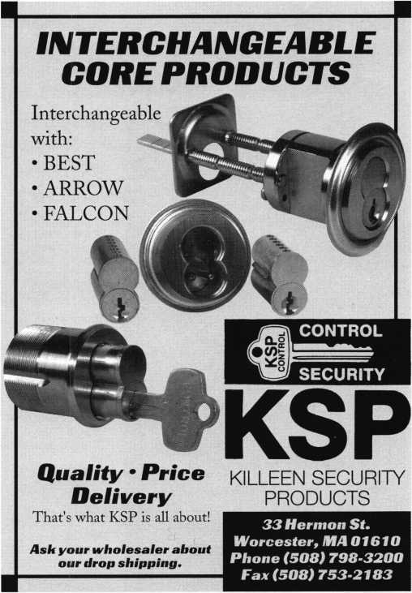

October 1999

Keynotes

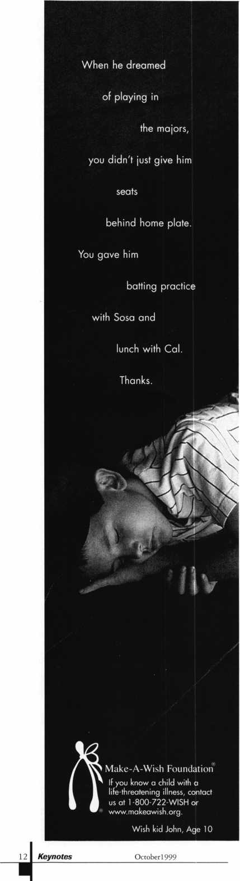

Applicants

For Membership

Dept

***The following applicants are scheduled for clearance as members of ALOA. The names are published for member review and comment prior to November*** *1****,*** *1999****, respectively, to ensure applicants meet standards of ALOA’s Code of Ethics. Protests, if any, should be addressed to the Membership Department and must be signed. Active Membership applicants (A) have worked in the industry two or more years. Allied Membership (AL) applicants are not locksmiths, but work in a security-related field. Apprentice Membership (AP) applicants have worked in the industry less than two years. A***

Clearing November 1:

USA

ARIZONA

Phoenix

Chris M McAllister, AP SPONSOR: Michael McAllister

CALIFORNIA

Los Angeles

Sion Bitton, A

Sunnyvale

Frank Sadigh, A

COLORADO

Breckenridge

Gary J Lorch, A SPONSOR: Christopher Wells

CONNECTICUT

Farmington

Bruce B McPherson, A SPONSOR: Charles McPherson

DISTRICT OF COLUMBIA

Washington

Borris L Ferrell, A SPONSOR: David Killip

FLORIDA

DeLand

Veronica L Jordan, AP SPONSOR: Dale Flood

Homestead

George C Camburn, A SPONSOR: James Barnhardt

Miami Beach

Antonio Marrero, A

Miami

Augustin E Medina, A SPONSOR: James Barnhardt

Orlando

Susan M Kieda, A SPONSOR: Larry Puckett

Panama City Beach

Drexel W Owens, A SPONSOR: James Barnhardt

Tampa

Michael L Van, A SPONSOR: Austin Curry

GEORGIA

Columbus

Joe E Earls, AP

Quitman

James B Archer, A

INDIANA

Rochester

David A Masterson, A SPONSOR: Robert Fisher

LOUISIANA

New Iberia

Kris M Smith, AP SPONSOR: Ben Payne

MASSACHUSETTS

South Dennis

Richard D Wolfe, A

MARYLAND

Odenton

Edward S Haney, A SPONSOR: Harold Fink

MINNESOTA

Champlin

Cory L Schmidt, AL SPONSOR: Timothy Donovan

MISSOURI

Fenton

George R Whitelaw, A

MISSISSIPPI

Booneville

Michael Filley, A

Starkville

Glynn W Hankin, AP

NORTH CAROLINA

Ashville

Bill Edmonds, A SPONSOR: William Chatham

Zebulon

Daniel S Fogleman, A SPONSOR: Joe Estridge

NEBRASKA

Lincoln

Francis S Nungesser, A SPONSOR: Michael McKinney

NEW JERSEY

Bloomfeild

Tom N Phillips, A SPONSOR: Charles Phillips

Somerset

Kenneth R Vitty, A SPONSOR: Glenn Hennings

OHIO

Cincinnati

David A Sickinger, A SPONSOR: Michael Rumage

Dayton

Don Kleismit, A

Franklin Furnace

Denver A Triggs, A

PENNSYLVANIA

Lititz

Shimshon Alpert, AP SPONSOR: William Neff

SOUTH CAROLINA

N. Charleston

Billy E Fowler, A SPONSOR: Robert Temple

TENNESSEE

Memphis

W H Davis, AP

TEXAS

Canyon

Wyndel K Gruver, A

Fort Worth

Harry L Shaw, A

Tyler

Douglas E McGuire, A

VIRGINIA

Arlington

Jeremy W Pollock, AP SPONSOR: Michael Groves Christopher S Robinson, AP SPONSOR: Michael Groves Ian M Walker, AP SPONSOR: Michael Groves

Salem

Dale L Bowman, AP SPONSOR: Clyde Roberson

KOREA

Tonghaee

Sang-Hi Park, A

UNITED

KINGDOM

Cardiff

Adrian Liewellyn, A



How Important Is Safety To You?

1

Safety - if it’s not your biggest concern, it  
should be. Not just your personal safety, but  
the safety of your company as well. We live in  
an age of outrageous lawsuits - why take  
chances with side-impact airbag systems? The  
Jiffy-Jak is a safe, easy to use and cost effective  
alternative to traditional car opening tools.

**SIDE-IMPACT AIRBAG FACTS**

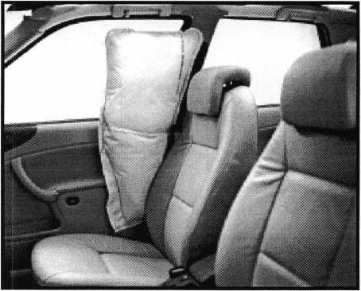

Deployed side impact air bag

* 31% of all vehicle accidents resulting in serious  
  injuries or deaths are side-impact collisions.
* Side-impact airbags can reduce these injuries by  
  as much as 40%
* Side-impact airbags have been in use on some  
  vehicles since 1997
* Soon, over 40% of all new vehicles will have  
  side-impact airbags
* Replacement costs for side-impact airbag systems  
  can run into thousands of dollars
* Potential liabilities for injury or death as a result of

the malfunctioning airbag could run into millions of dollars

**JIFFY-JAK VEHICLE ENTRY SYSTEM FACTS**

* Using the Jiffy-Jak completely eliminates the possibility of damaging a side-impact airbag system
* The Jiffy-Jak will not damage doors
* The Jiffy-Jak will not damage paint
* The Jiffy-Jak is the “fastest in the business”
* The Jiffy-Jak will safely unlock over 80% of all vehicles
* The Jiffy-Jak can open most cars in less than 60 seconds
* The Jiffy-Jak comes with a 90-day money-back guarantee



Tech-Train Productions P.O. Box 15401 Pensacola, FL 32514-0401

www. techtrainproductions. com

Toll Free Order Line: (888) 801-2003



Braa

UPS

*am*

Take the

Tech-Train Challenge:

Try the Jiffy-Jak Vehicle Entry System for 90 days risk-free. If you are not completely satisfied, send it back for a full refund.

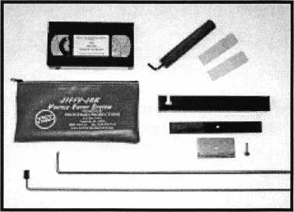

Jiffy-Jak

Introductory Price:  
Only $149.00

List Price: $169.00

The Locksmith Industry Advisory Committee

bat ft Is.

As with any industry, the security trade has its fair  
share of problems, organizational discrepancies and  
legislative issues. Although ALOA, its chapters and

various regional associations are structured to address such  
matters, there is still a committee dedicated to preserving  
industry ethics.

The Locksmith Industry Advisory Committee is designed  
to observe trends in the security industry, listen to complaints  
from various parties and provide counsel. It is duty bound to  
adhere to long-standing traditions and ethics as well as to make  
appropriate suggestions to maintain such practices. It should be  
noted, however, that LIAC is an ad hoc committee that

exists without bylaws and does not seek out  
problems, but rather responds when specifi-  
cally asked by individuals. This group of  
industry members donate their personal

time and effort to further the industry  
if the need arises.

“It’s a group of people that are  
involved in the locksmith industry.

Distributors, locksmiths and manu-  
facturers are all on the boards,” says  
15-year member and former ALOA  
President Stan Haney. “The  
committee is there to quell any

problems that arise in the industry. It’s  
just a good thinking group of people who  
sit down and discuss things and relate  
examples from their own industry.”

Although Haney (now an Honorary member) says

that during his time with LIAC, things have been relatively  
quiet, it’s inception in 1963 stemmed from a conflict that pitted  
ALOA and the Greater Buffalo Locksmiths Association against the  
New York Locksmiths Association, The Connecticut Locksmiths  
Association and the long Island Locksmiths Guild.

The main argument arose as a result of a heated dispute that caused each feuding party to schedule a convention on the same date and within the same state.

In an attempt to uphold a sense of unity within the locksmith community, a neutral team was assembled to solve the problem. This group included Leon Koch, Harry C. Miller, Ben Silver, Duane Mowat and Leonard Singer. Each of the conflicting organizations sought advice from the committee and after many suggestions and

proposals, the matter was settled.

The solution was that the rival conventions be held a week  
apart from each other to lessen the strain and competition  
between the organizations

Later that year, the group sensed a need within the locksmith

industry to serve as a permanent committee. On August 26,  
1963, the official LIAC came into being.

Since that time, the group has utilized its diverse make  
up to accurately address situations in various aspects of the  
security industry.

“Everything is usually done behind the scenes,” says current  
member and ALOA member, Steve Engel. “If an issue is

brought up, then the committee would perhaps take

it to specific individuals and these people would

communicate with the entities involved and  
make suggestions. They would not go in and

say you have to do this or do that. Rather,  
they would offer recommendations. It’s a

very soft approach but probably the  
most effective.

“For example, a few years ago, there  
was an issue where there were too many  
conventions and shows. Several of the  
committee members talked to distribu-  
tors and asked if they could cut back on

shows

for a year or two. A majority of them actually

did that.”

Meetings are held every year at the ALOA

convention to discuss issues and developments that may

affect a certain population of the locksmith/security community.  
“It’s a good mix of leaders who are there whenever there’s a need  
for any industry parties to come and speak their mind,” says Haney.

Members are selected though a nominating committee that selects new members each year and are elected on the basis of leadership, fairness and honesty in their business dealings. Officers are elected by the members. Three to six additional members are brought in each year to replace departing members (who usually leave due to time constraints, professional obligations and other reasons).

“This group is here to assist an assortment of industry professionals,” says Engel. “Not only ALOA, but other entities that deal with locksmithing as well.”

-4

141 Keynotes

October 1999



I

THE SOURCE FOR...

Sargent & Greenleaf

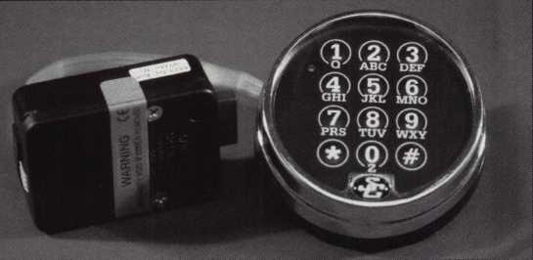

Comptronic Model 6123 Features:

multiple user

dual custody 0-99 minute time delay timelock interface*

Regular price S 187.40

Sale $134.95

**' requires an optional module and Time Commander II timelock**

IM E Time-Masler.tom (web) • [TIMSm@ool.com](mailto:TIMSm@ool.com) (email)

ASTER 888 798 8464/Fox 800 798 TIME(8463)• 785 232 8705/Fox 785 232 2603

**I**



**BE A PART OF 1-800-LOCKSMITH!  
USE THIS NUMBER IN YOUR CITY  
& OWN THE MARKET!**

We are looking for qualified locksmiths who want to expand their business

and develop themselves into one of the largest locksmith operations

in their city. You will be authorized to use our logo and name

and we will advertise for you on radio and television.

Interested locksmiths will be able to "secure"

as large or as small a territory as they

desire. Territories will be based

on zip codes.

**Call today for  
more information  
or to sign up!**

October 1999

Keynotes I 15



aboard!

**Steve Young is riding high with Tech-Train!**



**Intel view by Don Dennis. CPL**

The following interview took place compliments of the World Wide Web. With Steve’s busy schedule, this was the best way. Not only does it give us insight but it is very accurate since the answers are just as Steve wrote them. I am always curious about successful individuals, especially 47-year-old entrepre­neurs. I wanted to know more of Steve’s background and a little bit of how he came upon his success. I wanted to understand his sacrifice and some of his joys. The following biographical sketch was furnished by Steve and I applaud him and his success:

**16**1 **Keynotes October 1999**

“I began my career as a locksmith in  
1973, working for a company known as Lock  
& Gunsmith, Inc. I worked there until 1977  
doing residential, commercial and  
automotive locksmithing. In 1977,1  
returned to college at the University of  
Florida and graduated in 1979 with a  
Bachelor’s Degree in Zoology. During this  
period I put myself through college by  
working full-time as a locksmith and safe  
technician at the oldest and largest locksmith  
shop in the area, Rice Hardware. I returned  
to Pensacola and to Lock & Gunsmith, Inc.  
in 1979, where I became the manager. In  
1983,1 took a position as a Civil Service  
Locksmith at the Naval Air Station in

Pensacola. While working for the  
Navy, I spent most of my time  
servicing GSA security containers  
and other types of safes.

“In late 1987,1 began Tech-  
Train Productions as a part-time  
venture with the goal of leaving  
civil service as quickly as possible.

I eventually left the civil service  
system in January of 1989 to  
devote myself to Tech-Train on a  
full-time basis. Tech-Train  
Productions was originally set up  
to produce a series of videotapes  
for the locksmith industry that I  
had planned to use as the basis of  
a correspondence school. As Tech-  
Train grew, the idea of a corre-  
spondence school was dropped as I  
focused more on producing videos  
for the correspondence schools  
that already existed. I personally  
produce, direct and edit each of  
the Tech-Train videos.

“I gained my experience in  
video production through a

combination of on-the-job training and  
classes at Pensacola Junior College. Tech-  
Train Productions now offers 32 different  
video tapes which cover subjects such as basic  
locksmithing, car opening, steering column  
servicing, safe deposit lock servicing, VATS,  
door panel servicing, impressioning and air  
bag steering columns.

“Our line of tools began as a spin-off from our car opening videotapes. As Tech-Train has grown, so has our tool line. We now distribute a wide variety of tools from other manufacturers in addition to our own tools.

“From 1988 until September of 1999,1 traveled the country as an instmctor along with Bill Reed. In 1996, Bill and Caroline Reed moved to Pensacola, and together we

founded Security Resources. Since Bill’s untimely death on September 30, 1998,

I have tried to continue his program of bringing free education to locksmiths throughout the country.”

*Keynotes:* There is still a lot of confusion on the opening of the Toyota Camry. This is especially true in the 97-99 models. Have you developed anything new that will help in a speedier effort?

Steve: The Camry has always been a very challenging vehicle to unlock. The newest Camry, introduced in 1997, is the worst ever. Many locksmiths dread getting a call for one of the new Camrys. In 1997, we introduced a

tool for this car, the TT-1021, that works very well, but requires a great deal of patience. It even takes me a while to unlock a Camry with the TT-1021. With that in mind and with the advent of side-impact airbag systems, I have been experimenting with different opening methods that do not involve going into the door cavity.

The result is our new “Jiffy-Jak Vehicle Entry System.” Basically, the Jiffy-Jak uses a system of levers made from a space-age poly­carbonate resin to open a gap between the door and the doorframe. Once the gap has been opened, it’s child’s play to unlock most vehicles with a long rod tool. At the recent ALOA show in Cincinnati, we had a 1999 Camry in our booth. I spent the entire show

repeatedly unlocking this car with the Jiffy-  
Jak. During the show, I unlocked that car

more than 300 times with no damage to the  
car; my average opening time was about 30  
seconds. The Jiffy-Jak can be used in the  
same way to unlock about 80% of the  
vehicles on the road today.

*Keynotes:* Does this mean that the Jiffy-Jak  
will be replacing more traditional car opening  
tools?

Steve:I don’t see the Jiffy-Jak as a replace-  
ment for traditional car-opening tools.  
Instead, I see it as another weapon in the  
locksmith’s arsenal of tools. With all the

concern about side-impact airbags,  
plus all of the wires, cables and  
fiber-optic leads that are now used  
inside of car doors, there are  
compelling reasons to avoid using  
tools that go into the door itself.  
The Jiffy-Jak provides a safe,  
simple and effective way of  
unlocking most vehicles very  
quickly and without damage.

*Keynotes:* Key head transponders  
are becoming more and more popular  
with the manufacturers. Will you be  
coming out with any tools to help in  
the reading and programming of these  
items?

Steve: I have no plans at present  
to market any tools of my own for  
these systems. We do market the  
“ETD-1 Transponder Decoder and  
Duplicator,” manufactured by Jet,  
which allows the locksmith to  
duplicate many different types of  
transponder keys in much the

same way as regular keys are duplicated.

The transponder systems are changing so  
rapidly that it’s just not practical for me to  
try to devise my own programming tools.  
Because the programming systems are all  
computer-based, it’s the software rather than  
the hardware that really makes the difference.  
In the case of Ford, the programming  
software changes at least twice per  
model year.

Since the programming code itself is  
protected by copyrights, it’s virtually  
impossible for anyone to legally market a  
product for the Ford system without Ford’s  
help and approval. At this time, Ford has  
neither an incentive nor a desire to work  
with anyone in the security industry on such

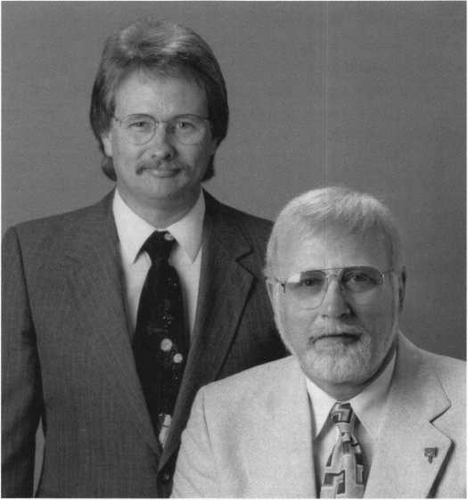

Dynamic Duo: Steve Young and the late Bill Reed founded Security Resources.

October 1999

Keynotes

a project. Fords official policy on transponder systems is that they should always be brought back to the dealership for any service—including duplicate keys.

So far we have heard very little from the public regarding the inconveniences caused by transponder systems. I personally think that is about to change. There are already isolated news stories cropping up in the media of some of the “horror stories” that some owners have endured because of the lack of available service for these systems. I suspect that like the problems with airbag injuries and fatalities, eventually we will reach a point of “critical mass”, and suddenly, the negative side of transponder systems will become a hot news item. Hopefully, a little public backlash will convince the manufac­turers to make service information and equipment more readily available to security professionals.

*Keynotes:* What tools will you he adding to your opening kit for this coming year?

Steve: At this time I don’t have any idea. Because I only introduce new tools when I feel that they are essential, I v/on’t know if any new tools will be needed until I have a chance to take the 2000 models apart. We survey all the new vehicles as they are introduced, but most of the new cars for the 2000 model year won’t be out until December or January.

In fact, the two biggest auto shows in the world are held during the first two weeks of January each year. It is then that the majority of the new cars are introduced. I spend a great deal of time at the auto shows, dealing with the engineers and factory reps in order to get access to these vehicles as soon as they are announced. For that reason, when our manual is published, it traditionally covers vehicles that won’t be available to the public for six to 10 months. For instance, our 1999 manual covers the 2000 Chevrolet Impala, Nissan X-terra, Toyota Echo, Ford Focus and several other vehicles that didn’t go on sale until mid to late summer. As far as new tools for 2000 are concerned, if any are necessary I’ll be announcing them near the end of January.

*Keynotes:* Are side impact air bags in our future for all models and manufacturers?

Steve: They may never become standard equipment on all cars, but they are definitely here to stay. I expect to see some type of passive side-impact protection system on all

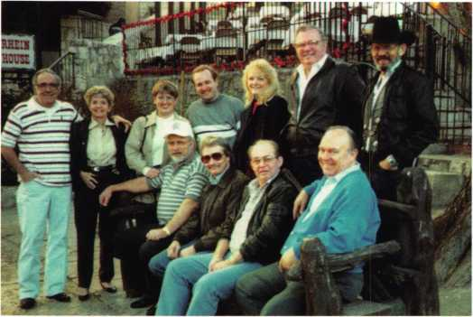

A winning team: Thanks to friends, supporters and partners, Steve Young keeps Tech Train a rollin’.

but the lowest priced  
vehicles within a  
matter of a few years.

*Keynotes:* In working  
with the side impact air  
bags, will you or do you  
have any tools for making  
this effort easier?

Steve: As I said  
earlier, our new  
Jiffy-Jak allows the  
locksmith to unlock  
most cars without the  
danger of inserting  
tools into the door  
cavity. I personally feel

that it is very unlikely that a competent  
locksmith would actually damage a side-  
impact airbag system. The main danger, as I  
see it, comes from the possibility of a  
locksmith getting stuck with the blame for  
damages caused by an amateur car-opener.  
When we answer a call for a lock-out, for all  
we know the car owner may have had  
someone “working” on the car for hours  
before calling in a professional. Using a car  
opening method that doesn’t require  
inserting a tool into the door cavity effec-  
tively eliminates a locksmith’s liability for  
damage to airbag components contained  
inside of the door.

*Keynotes:* The after market in the auto industry is getting more expensive to operate in. We have overcome the requirements of VATS and now we are fighting the woes of the transponder. Some locksmiths are joining forces to have the machinery to work in this field. Is there anything that your company can offer to help in reducing the problems of cost?

Steve: Not at this time. However, I do plan to put out as much information as possible in both print and video formats to help locksmiths as they deal with these new systems.

*Keynotes:* What direction will Tech-Train be taking in the near future? Will there be any special videos for this year or for 2000? Will you be giving any educational classes? Is there a schedule?

Steve: I have several videos in various stages of completion right now. Two of the most eagerly anticipated are our tapes on picking and on the two and four-track Mercedes lock systems. Both of those tapes

should be out before spring. In addition, we plan to offer our video library in a DVD format very soon. That will allow a locksmith with a properly configured laptop to view the information in our videos at the job site.

As I write this, I’m in the process of planning our seminar schedule for 2000. Once again, I expect to be teaching a free seminar or attending a trade show at least twice a month. If any associations want to schedule a free Steve Young seminar, they need to contact me as soon as possible at (800) 356-0136. I’ll be posting a schedule on our web site at hyperlink <http://www.techtrainproductions.com> as soon as I have it ready.

*Keynotes:* Do you see any trends in the automotive market that the locksmith needs to pay special attention to? This would be in cost as well as education.

Steve: From where I sit, I expect to see the division between automotive and non­automotive locksmiths widen. As the sheer volume of information that is needed by an automotive locksmiths grows, there are going to be fewer locksmiths willing to make the considerable investment in both time and money that it will take to be successful in the automotive field. But for those who are willing to put in the effort to stay abreast of the new trends in automotive security, the rewards will be well worth the effort. More than ever before, education is the key to higher earnings in the locksmith industry. I plan to keep providing the highest possible quality in educational videos, books and software so that my customers can prosper in the brave new world of high-tech automotive lock systems.

Keynotes

October 1999

gjaBjlB

By Michael Ferrill

As Americans, we assume because of our national makeup that we have produced some of the finest lock sets in the world. To be truthful, we have indeed. However, because of our world becoming smaller through the use of telecommunications, and the Internet we are finding out there are indeed other lock makers in the world that can stand alone on pride of workmanship and make similar claims to producing some of the finest locks in the world today.

With that in mind, I would like to profile the Jackson Lock Company, manufacturers of quality locks in the country of Australia since 1883.

Francis Jackson, the founder of the lock manufacturing industry in Australia, was born in Wolverhampton, England in 1851. He served his apprenticeship as a locksmith with Mr. B. Smith in that city, and was later employed as a foreman locksmith with Chubb (England’s

Keynotes

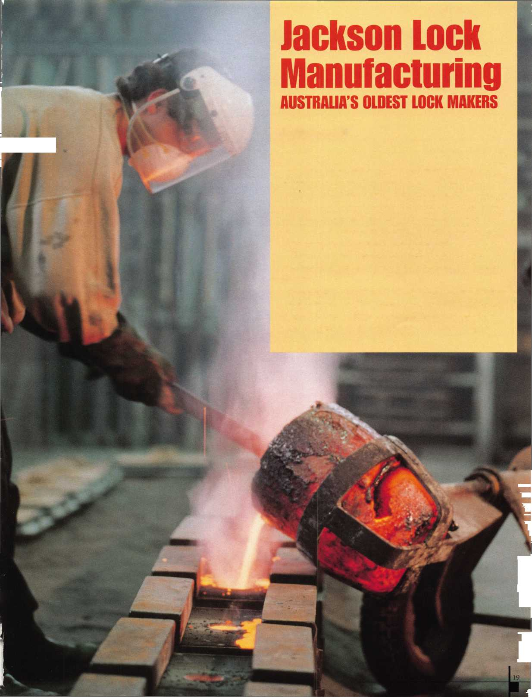

premier lock manufacturer). In 1879, he was  
accepted by the Japanese Government to  
travel to Japan to teach artisans in Tokyo the  
art of lockmaking and the manufacture of  
brass fittings. He arrived in Japan in January  
1880 and completed his contract in  
December 1882. Instead of returning to  
England, Francis sailed to Australia, and  
settled in Launceston, Tasmania. He sent for  
his wife and four children to join him. They  
arrived in 1883 on the sailing ship Glen Goil  
after ten weeks at sea.

In 1883, Launceston with a population of  
12,000 was in the grip of a depression, with  
wages at 50 cents a day. Francis rented a shop  
at 74 Charles Street, for the sum of $1.00 a  
week rent. Shortly thereafter after a  
period of six months, his first

opportunity to sell his  
manufactured locks came when one

of the local railroad companies  
ordered point locks (large padlocks)  
from him. These were priced at 68  
cents each. His prestige grew  
within his community when the  
Beaconsfield Bank asked for his  
assistance to open a “unpickable”  
lock on their safe, after a bank  
robber had thrown the keys away.

Francis opened the lock to  
everyone’s astonishment. He was  
immediately ask to provide  
additional locksmithing services to  
several other banks within the

community. His reputation as a locksmith  
and lock maker grew.

Being a gifted tradesman in this field, he continued to develop lock manufacturing and provided lock repairs. He also carried out all types of repairs to household and office goods. He installed electric bells (early entry alarm systems), repaired sewing machines, repaired and service guns, being an accomplished gunsmith.

Francis Jackson was responsible for the preparation of two display cases of hand made cabinet, safe and padlocks in the 1880s and won medals for their quality at Exhibitions in the Melbourne, Launceston and Wembley (England). The company still has these two display cases in their showroom today.

Mr. Jackson’s company continued to grow with much success. His son, Davis Sydney Jackson came into the business in 1910, and “Syd” was later to become managing Director. Syd also became a member of the Australian Federal Parliament at its foundation in 1919- He spent much of his time in Parliament, and assisting with many local charitable and business organizations within his community. During the coming years, James Eric Scott (Eric) managed the business, and when Syd Jackson died in 1941, ownership of the company was passed to Eric Scott. Eric died in 1956 and the company was passed on to his four sons, Eric, Herbert, Bruce, and Neil, who were all

“In 1883...HIS prestige grew within his community when the Beaconsfield Bank asked for his assistance to open an ‘unpickable' lock on their safe after the hank robber had thrown the keys away."

working for the Jackson’s.

The business at this time was located at 106 Cameron Street in Launceston, and working space became scarce. Aside from manufacturing all types of locks, the company also had a motor spring shop and provided general repairs to a number of mechanical devices, gunsmithing and general locksmithing. In 1966, a factory was built at 169 Ravenswood Road, Launceston for the manufacture of locks only. In 1991, it was decided to divide the old Jackson’s Lock & Brass Works PTY, LTD. into companies related to their specific type of activities. The lock factory was named Jackson’s Lock Manufacturing PTY. Ltd. and the owners are Michael and Wendy Scott, and Neil Scott

Like most companies, which have

survived over 100 years, change has been the  
continuing secret to their success. In the  
early post war years, the Jackson Lock  
Company manufactured large quantities of  
cabinet and padlocks. With the increase of  
competition from developing countries and  
the lowering of tariffs special locks were  
developed and changes are continuing being  
made in the production of fine quality locks  
by the Jackson Lock Manufacturing  
Company. Michael Scott has been responsible  
for the development and quality  
workmanship of the Jackson Lock company  
for the past twenty years.

This story could be repeated over time  
and time again, because it mirrors the early  
start up of so many of our fine  
American lock companies. In

America our lock industry  
continues to face the same

challenges in the manufacturing  
and reproductions of our locks  
throughout the world today.  
Competition in the world market  
today is healthy because it promotes  
and requires change.

In our industry today, the old  
world craftsman the “locksmith” is  
now expected to become  
knowledgeable in a number of  
various new and innovating fields  
within this trade. Today the  
overseas market continues to make  
inroads within our country as well

as other countries. They can offer numerous  
types of locks at cheaper prices, yet they are  
manufacturing good quality locksets. We  
frowned upon the Japanese in the early ’50s  
and ’60s with their reproductions of our  
goods. Yet they learned about our market  
and developed outstanding goods at  
reasonable prices that we as American  
purchased based upon quality, and quantity.  
Lets not forgot the quality of craftsmanship,  
that will always attract the consumers  
interest and buying power. The Chinese and  
Taiwanese are becoming more proficient in  
the reproduction and manufacturing of good  
reliable and quality locks. We should not  
become complacent within our industry as  
locksmiths or as manufacturers of locks in  
our country, or in the world today. Made in

Keynotes

October 1999

American simply means just that.

Investment now and for our future is needed and necessary. Investment now in the manufacturing of better locks, will maintain market share. Most importantly what is now needed today in our industry is the establishment and development of educational programs, for our locksmiths, by all American Lock Companies. This will improve product knowledge and certification in your company products. With this additional training established by major lock makers, and manufacturers of locks and hardware products our locksmiths will continue to improve upon the quality of standards of your companies, and enhance our trade and professionalism and industry stature within the world.

We should continue to remember within the world today there will always be good manufacturers of locks though out the world. Like the Jackson Lock Manufacturing Company in Australia, we should continue to provide outstanding quality locks to the consumer, based upon product designs, development and reliability. Please don’t forget the consumer is now the world, and if we are to maintain and manufacture locks in this new and expanding world economy we should continue to ensure our success by developing and producing better locks. Also don’t forget the additional training and certification required by our locksmiths that will continue to enhance their experience, training and professionalism. And finally lets not forget the quality of craftsmanship that we pride ourselves on. Like other nations throughout the world they will also continue to pride themselves on the quality of their products, as well.

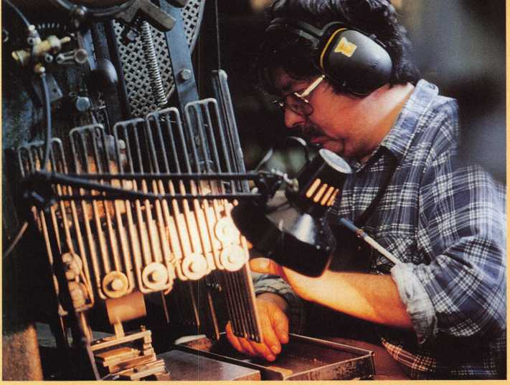

Devout craftsmen have long been a part of the Jackson tradition**.**

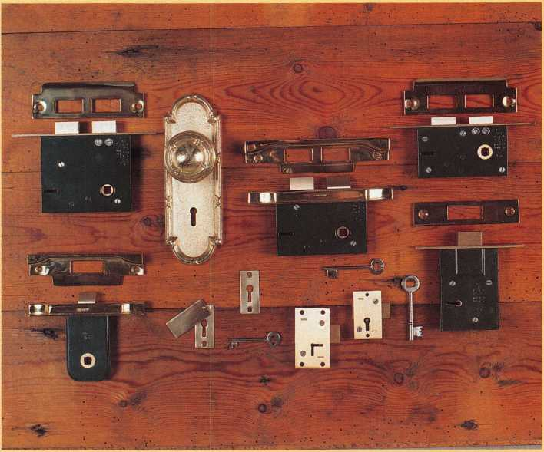

Samples of Jackson's Lock Manufacturers' fine work.

***To contact the Jackson Lock Manufacturing PTY LTD,***

***you can email:***

**[jacksco@microtech.com.au](mailto:jacksco@microtech.com.au)**

**or use their Internet address: <http://www.microtech.com.au/jacksonsJocks>**

***You can also write direct to:***

**PO Box 522,171 Ravenswood Road Launceston, Tasmania, 7250, Australia**

**Or reach them by telephone at: 03.6339.1662, FAX 03.6339.3444**

**Locksmiths would be wise to add this fine lock company to their list of available lock manufacturers, based upon quality and exceptional customer service to this industry.**

October 1999

Keynotes I

**by Sal Dulcamara, CML**

The Determinator. It seems to be a somewhat ominous name for a tool. It is, however, a clever and effective tool. It works on the principle of disc tumbler reading, but it doesn’t cause eye strain. It is a specially modified key blank that acts as a feeler gage. Photo 1 shows a set of three Chrysler Determinators. Surprisingly, you don’t use all three on the same set of locks. For 4-depth disc tumbler locks (like Chrysler and many others), only one tool is needed. The first time I looked at it, the exact principle of operation didn’t register. There are four depths, I thought, why wouldn’t there be a set of four keys? Then everything clicked when I realized that they took advantage of the tolerances of disc tumbler locks and worked in half depths.

Except for the positions of the notched cutouts of the keys in photo 1, they are otherwise identical. The variations are there to account for locks with different tumbler arrangements. If you look at any one of the notched cuts, you will realize that the surface to the left (inside surface of cut closest to tip end) is a blunt 90 degree angle, while the other side is angled at about 45 degrees. If we were doing a bit of trouble shooting, we might think we were dealing with a mis- cut key. Now what would happen if you tried to insert such a key into a disc tumbler lock? The answer is that if we tried to insert the key, the angled slope toward the bow side of the cut would lift the tumblers as the key surface slid neatly underneath the tumblers. It wouldn’t halt until the tip surface of the key hit the (back) stop surface inside the keyway of the lock. Apparently, no problem. Now what happens if we try to pull it back out? Of course it would be trapped, you say, since the steep 90 degree angle cut would grab onto a tumbler. There is obviously no relief angle on that side of the cut to release the tumbler. Well, you can’t really say that without a bit more information.

How a Disc Tumbler Works

Figure 1 shows the general layout of a disc (wafer) tumbler. The rectangular opening in the center of the tumbler is the path through which the key travels. The tumbler arm extends outward from the main body of the tumbler and sits on a tumbler spring, when in the tumbler slot. An arrow identifies the inside surface of the tumbler where the key makes contact. The height between that surface and the top of the tumbler (as shown in the illustration) is how the “size” is measured for a disc tumbler. To the right (at the top) of the tumbler, are markings to show the relative height for the #1, #2, #3 and #4 tumblers. If you look to the left of the indicator marks, you will see that the illustrated tumbler lines up with the #4 indicator mark.

Figure 2 shows a visual comparison of four different size tumblers, labeled to show their sizes. Side by side, there is no effective difference in height between a #1, #2, #3 or #4 tumbler, if measured top to bottom. If you look back to figure 1 showing how the size is

*A.*

Size

Measured

Here

Tumbler

Spring

Tumbler

Arm

Key

Makes

Contact

Here



**PHOTO 1**

**PHOTO a**

**PHOTO 3**

measured, you will see that the height of the material at the tops of the tumblers is different in every one. When there is no key in the lock, the tumbler spring tends to position all the tumblers in a row so that the actual top and bottom surfaces of the tumblers are the same height. If you could look into the keyway, though, the greater height of a #4 tumbler would be apparent. Like a window shade, it would drop farther. A #1 tumbler, by contrast, would drop very slightly into the keyway. If you could identify the tumbler size by figuring how far it drops into the keyway, you would be practicing what is called sight reading of disc tumblers.

Proficiency in sight reading is not a widely held skill among most locksmiths. It takes practice to become good at it. The Determinator is a tool that takes advantage of the principles involved in sight reading, but makes things a bit easier. Trapping a Tumbler

Back to the Determinator tool, and whether or not it would be trapped. Since we now know that different size tumblers drop into the keyway at different heights, we should be able to determine if and when the tool would trap. If a disc tumbler drops into the steep 90 degree angle cut, and the height of the key blade (beyond the cut) is in the path of the tumbler, the key will trap. If the height of the key blade is below the path of the tumbler, the key will not trap.

If you cut the height of the key blade (past the notch cut) to exactly how far the #4 tumbler drops, it would just slide under a #4 tumbler. Since the #4 tumbler drops the lowest into the keyway, if it wouldn’t trap a #4 tumbler, it wouldn’t trap any. If you raised the height of the key blade to just above the height that the #4 tumbler drops, it would only trap #4 tumblers and slide under the three sizes that were positioned higher. If you made the height of the blade just a bit higher than the height that the #3 tumbler drops, it would trap #3 tumblers. Because #4 tumblers drop even further than #3 tumblers, they would also be trapped. Since #2 and #1 tumblers are positioned higher, it would slide under those tumblers without trapping.

When dealing with a disc tumbler lock that uses four sizes of tumblers (like Chrysler), there is just one Determinator tool needed for decoding. The decoder key is designed as mentioned in the last example just above. The height is set so that #3 and #4 tumblers will trap, but #1 and #2 tumblers will not. The surface of the Determi­nator decoding key is stamped with the tumbler positions so that when it traps, you will see what position tumbler is doing the trapping. If a tumbler traps, you know it must be a #3 or #4. If the Determinator pulls outward without stopping, you can probably presume that each position that it passed without trapping must have been a #1 or a #2.

Figure 3 illustrates how the tool works. In “A”, you can see the Determinator about to inserted. To its right is a disc tumbler lock. The tumbler sequence, front to back, is as follows: 2 3 4 3 1 3 2. You can see that the #4 drops the lowest, then the three #3's are just a bit

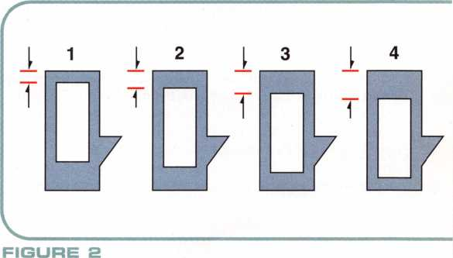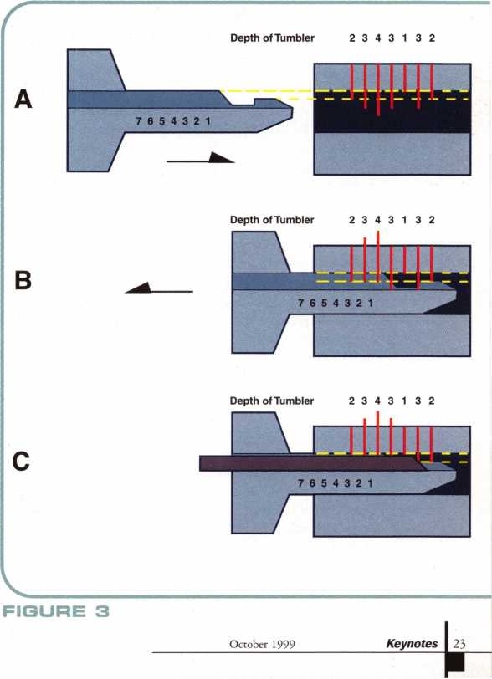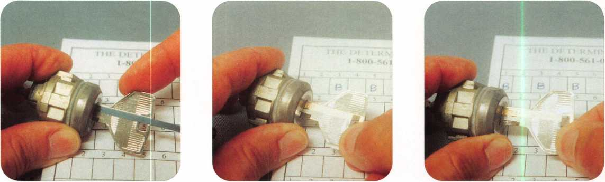

**PHOTO PHOTO B PHOTO S**

higher, two #2’s even higher and the single #1 tumbler is the highest. The dotted line shows the height of the key blade. Only the #3 s and the #4 tumblers cross the dotted line. That should indicate that they would be trapped, while all the others wouldn’t.

In “B”, after the Determinator is fully inserted, an attempt is made to withdraw it. In this case, the tumbler in the sixth position traps. You can tell that it is the sixth position, because the #6 is lined up with the front face of the door lock. When a tumbler traps, the number you see in that spot tells you the tumbler position. The drawing indicates it to be a #3 tumbler, but all the locksmith using the tool would be able to determine would be that it was either a #3 or a #4.

The trick now is to untrap the tool so you can decode the remaining tumblers. That is accomplished in “C” with a tapered (spring steel) slide tool that lifts the trapping tumbler so that the tool can be withdrawn further. The process would then be repeated by withdrawing the Determinator tool just far enough to disengage the trapped tumbler. The slide tool would be removed and the Determi­nator would be withdrawn further until another tumbler trapped.

Although not shown, it would slide under the tumbler in the fifth position which is a #1 tumbler, but would trap the fourth position which is also a #3. After releasing, it would trap again in the third position, which is a #4 tumbler. Next, the second position tumbler (which is a #3) would trap. The tool would have to be disengaged one more time. Finally, only one tumbler position would be undeter­mined. If it trapped, it would have to be a #3 or #4; if it just slid out, it would have to be a #1 or #2. In this case, it is a #2, so the tool would slide out. The Test

So far, I’ve given the theory behind the Determinator. Next will be an actual test on car locks to see if it works as intended. Before I start, let me make a few important points. I’ve shown how different size disc tumblers are supposed to drop into the keyway at different heights. The presumption is that the lock is in proper working condition, and if that is the case, everything works as planned. If tumblers are sticking and don’t drop as far as they are supposed to drop, however, you will get false readings. This will occur whether you are looking into the keyway and using your own eyes to read the tumblers, or if you are using the Determinator or any other tool that works on a similar principle. If you are looking at (or decoding with the Determinator) a #4 tumbler and it drops no further than a #1 tumbler, it will be decoded as such. To be more certain, you can take preemptive action. You can lubricate the lock first and use a pick or probe to work the tumblers up and down to make sure they have full motion. Otherwise, you can take things for granted and check for problems only if you fail to fit a key.

The locks I used were Chryler (7-cut key style) locks prior to 1993. The locks had double throw disc tumblers, with the following tumbler arrangement: door locks-tumblers in positions 1 to 5,

*A* Keynotes October 1999

ignition lock-tumblers in positions 1 to 6, trunk lock-tumblers in positions 3 to 7. The Chrysler Determinator that I used is shown in photo 2. The tumbler positions marked on the side of the key are: 1, 2,3,4 and 5. Remember to read all the directions carefully. Each Determinator has individual instructions. For the locks that I had, the Determinator would only be used to decode the door lock(s).

That means I could get no more than five of the seven total cuts. The remaining two positions would be reached by progression methods. I will show and explain the various steps to making a complete key. The Chart and Half Depths

I indicated earlier that the Determinator will give a (seemingly) vague determination. If a tumbler traps, the determination is that the tumbler is either a #3 or a #4. Since the specific value is initially unconfirmed, the letter “B” will indicate that it is one of those two values. If the tumbler doesn’t trap, it is either a #1 or a #2. Until confirmed, one way or the other, the letter “A” will indicate one of those two values. The chart in the background of photo 3 has a series of marked boxes indicating tumbler positions. It can be used for locks/keys having as many as ten tumbler positions. For the Chrysler keys, only seven positions will be needed.

Photo 3 starts the decoding process. The Determinator had already been inserted. When I attempted to withdraw the key from the lock, it stopped immediately. It is not perfectly legible in the picture, but the number “5” is positioned at the opening of the lock. That means that the tumbler in the fifth position is trapped. As mentioned earlier, the letter “B” will represent trapped tumblers. As such, I have written the letter “B” in the box marked “5”.

I used the slide tool, in photo 4, to disengage the tumbler. Before removing the slide tool, I moved the Determinator out slightly. It was just enough back so the same tumbler would not drop in again. With the tool released, I continued pulling it outward until it trapped again, in photo 3. This time the third tumbler trapped. I wrote the letter “B” in the third box of the chart.

After disengaging the tool again, I pulled again until it stopped once more. Photo 6 shows the first tumbler trapped. The chart shows that I wrote a “B” in the first box. Before you presume that the second and fourth positions must be “A”, realize that there are double throw tumblers. The tool must be turned upside down and reinserted, before we can determine what is in those two positions.

Photo 7 shows that the Determinator is inserted in the reverse position. When pulling back, it stopped in the fourth position. A letter “B” can be found in the fourth box. After disengaging the tool, I continued pulling until the Determinator until it passed all the marked tumbler positions, in photo 8. No more tumblers trapped. The remaining blank box had been in the second position, so I wrote the letter “A”.

The chart shows the five tumbler positions as such: B A B B B. Here is where the half depths come into play. If you have ever used

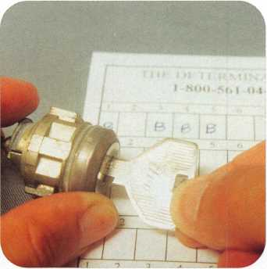

**PHOTO 7**

automotive tryout keys, you may know that they usually use half depths to represent two different depths. Because of relatively sloppy tolerances in many auto locks, a 1 1/2 depth will usually pass for either a #1 or a #2 depth. The same goes for a 3 1/2 depth working for a #3 or a #4 depth. Where the letter “B” indicates either #3 or #4, a 3 1/2 depth will be made. For the letter “A”, which represents either #1 or #2, a 1 1/2 depth will be made. In photo 9, the key has been cut as follows: 3 1/2,1 1/2,31/2,31/2,3 1/2.

The next step is to try out the key that was made using half depths. The key turned in the door lock, but it was a little sticky. After removing the key from the lock, I looked to see if there were any impression marks. I found none, so I presumed that the depths were a half depth shallower rather than deeper. Just above the letters “B” or “A”, in the boxes, you will see the numbers that represent a depth that is 1/2 depth shallower than the letter below it. I cut a new key with the cut pattern: 3 1 3 3 3, and tried it in the door lock. It worked perfectly smooth.

I still only had five of seven cuts, so the next step involved progressing the sixth position cut. The ignition lock has tumblers in the first six positions. Since I already had five of the necessary six cuts to operate the ignition, I only had to progress the sixth position a depth at a time until the lock turned.

I first used the key as is, because the blank surface of the key is already equivalent to a #1 depth. The key I identified as: 3 1 3 3 3, was technically already cut to:313331 1. When I tried to turn the ignition lock, it wouldn’t. That meant that the sixth position cut was deeper than a #1.1 cut it deeper to a #2 depth, and tried it in the ignition lock again, in photo 10. It turned, so I added the #2 in the sixth position box. The known cuts were: 3 1 3 3 3 2.

I now had six of the total seven cuts. The trunk lock contained the tumbler in the seventh position, so I could use that lock to progress the final cut. As mentioned before, the blank surface of the key is equivalent to a #1 depth. The key I now had was technically cut to the following pattern: 3133321.1 tried the key in the trunk lock, and it wouldn’t turn. I cut the seventh position cut to a #2 depth and tried the key again. It still wouldn’t work. I took it one depth deeper to a #3 depth. This time it worked. The cuts were: 3 1 3 3 3 2 3.

The step by step description might make the reader think that the process of decoding and fitting keys took a rather long time. In fact, it took about five minutes. Now that didn’t count the time I spent before hand reading the instructions and viewing the demonstration video. The thing is that once I understood the process, it went extremely fast. In fact, it was much faster than I would have otherwise expected. Now I wouldn’t presume that every car would go that way, or every locksmith’s experience would be the same. In fact, Ford locks use five depths, so the process is a bit different and involves two different Determinators. There are some limitations, depending on the type of key cutting equipment that you use. I was using a motorized code machine capable of cutting half depths. If you use a Curtis Clipper or A-l Pack-a-Punch, you may have to work with full depths. If you use depth keys, the company does sell special depth keys with the half depths.

I can say that I was pleasantly surprised and rather impressed with the Determinator. I tried the tools on another set of Chrysler locks with similar results. Determinators are available for a variety of domestic and import car locks. If you would like additional informa­tion on the Determinator, you can contact: The Car Openers, Inc., P.O. Box 895, Ocoee, FL 34761. Phone: 800/561-0443.

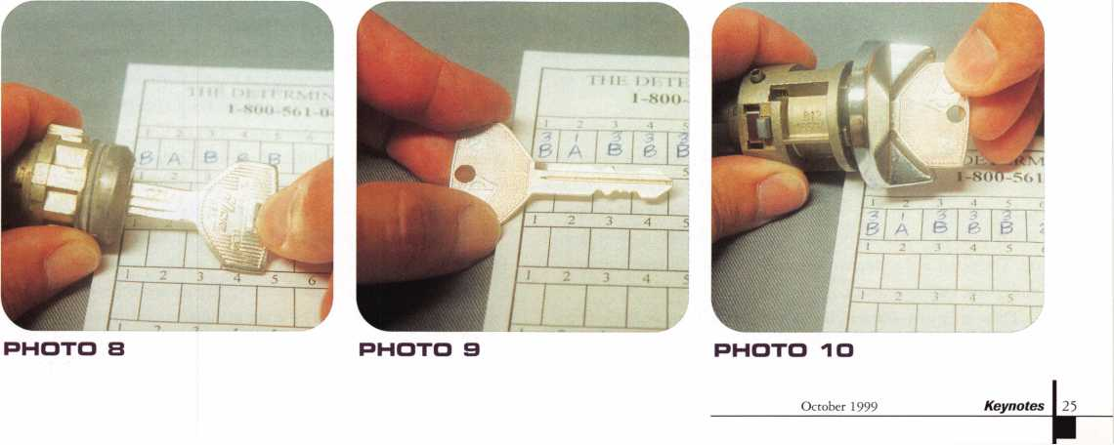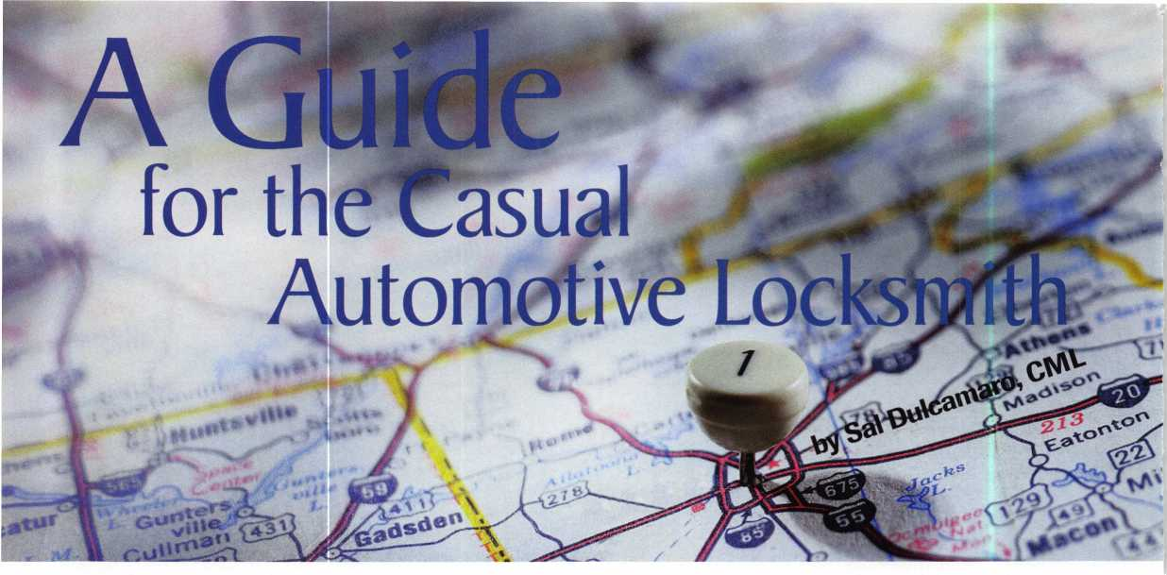

When I started out in locksmithing, back in 1975,1 did a little bit of everything. Auto lock work was never a majority of my business, but I did my fair share of it. At the time, almost all of it was domestic auto locks and keys. As we reached the middle 1980s, the percentage (and variety) of import cars grew dramatically. Still, the domestic cars were not overly exotic and complicated, and neither were the imports.

With electronics and transponders taking center stage, it is a much different world now when it comes to auto locksmithing. If you want to be a full service automotive locksmith, you are going to be looking at a fairly heavy investment in new equipment. If you can’t or won’t fork out the cash to acquire all this new (and expensive) equipment, though, it doesn’t mean that you have to quit doing auto lock work. There is a sizable chunk of auto locksmithing, at least for now, with which you can continue on a small budget. You won’t be set up to do everything automotive, but as a casual automotive locksmith you can have the tools you need to do quality professional work, without getting in over your head. And you can still make a decent profit.

**® Knowledge Is Power**

Strictly speaking, it might not be considered a tool, but knowledge/information can be your most valuable and powerful tool. That could include anything from taking a class, to owning books, magazines or software.

In years past, I would quote prices for auto lock work without being overly concerned about making a mistake. Today, I wouldn’t even dream of quoting a price, without first asking a lot of questions and then looking up the information I needed. Few of us have the ability to store, in our brains, all the information about every type of car. Thorough and accurate reference materials will save you time, money and embarrassment.

There are many different books and publications available from various sources, ranging from free to extremely expensive. Let’s review what is available in the very lowest price range: free. There are

26 I KeynotesOctober 1999

reference guides, booklets and catalogs available from most of the companies that manufacture products related to auto lockmithing. The products include key blanks, locks, tools and service kits. Some companies include useful technical information such as a listing of what makes, models and years use a particular type or design lock; descriptive charts providing a list of code series used for different vehicles; or basic key fitting or lock servicing information.

There are the reference guides and booklets where there is no obvious product being promoted or offered for sale. What it does is give you useful information for free, and if effective, it generates good will back from the locksmith to the company and possibly generates a future sale. One free reference guide I’ve found that particularly stands out is Ilco’s 1999 Auto/Truck Reference, shown in photo 1. It’s a publication that is updated every year, and I’ve been using them for years to help me find out what keys go with which cars. This particular edition has made some interesting improvements over previous editions. The layout of the pages has been changed from portrait to landscape. In other words, you open it like a calendar.

The content has also changed. It now provides programming instructions for most domestic and import transponder keys. They include adding duplicate keys and also how to proceed when no keys (or less than the number required for standard duplicating procedure) require that you start from scratch. Other system programming procedures are on the pages that follow. The rest of the booklet is an alphabetical listing of the many domestic and import cars and trucks. Information in the many different columns include model and year, lock applications (which keys operate which locks), code series, a few columns of cross referenced key numbers, transponder information and possible substitute key blanks. That is a lot of useful information for the price of “free.”

You should be able to get the Ilco reference and other catalogs and reference guides (produced by other manufacturers) free from your local locksmith supply company. If they don’t have them, contact the companies directly. Besides Ilco, companies like STRATTEC, BWD

(formerly ALL LOCK), ASP (Auto Security Products), Hurd and others also put out auto related catalogs and literature, which are usually supplied at no charge. Not all of them will be of equal importance, but “free” is a pretty good price and it can’t hurt to check them out.

**® It’s Not an Expense, It’s an Investment**

There are limits to the value of materials that you get for free. Beware of being “penny wise but pound foolish.” Not spending money to buy information you need can ultimately cost you more money further down the road.

Photo 2 shows an opened three ring binder containing a publication called AutoSmart. Atop it is the abbreviated version called MiniSmart. It is produced by Michael Hyde, one of the leading experts on automotive locksmithing. I don’t believe there is any other single publication that is as valuable a resource to the automotive locksmith. If you heed its advice, it will help you make money, and keep you out of trouble.

AutoSmart is divided into sections with the various domestic and import vehicles in alphabetical order. It contains most of the information that you will find in the different free pamphlets and catalogs, but also explains key fitting procedures for the various cars and trucks.

Some examples of the type of information found in AutoSmart can be seen in photo 2. Key information is provided, but so are the tumbler arrangements. This lets you know how many and which locks are required in order to make a complete key. It provides information on code number locations. It shows if and where the code numbers might be found. Key fitting procedures are listed, with usually a few suggested alternative methods.

Hyde usually lists the methods in order of ease and practicality, however, if you just happen to be lacking in the skill needed for method 1, you could likely find a method on the list that is better suited to your particular skills. You’ll also see warnings in certain sections. Let’s say that you often fit keys by impressioning. You may see a warning that a particular car has locks with very thin tumblers that bend or break easily. It could give you a more practical alternative and save you from damaging a lock on your customer’s car. There are also car opening hints, although I wouldn’t consider it a replacement for a car opening tool set.

Another useful publication, found in photo 3, is called Fast Facts by Robert Sieveking. It is a very compact, pocket-sized booklet that contains a great deal of information on most import and domestic vehicles. It doesn’t go into the level of detail found in AutoSmart, but it can be a very handy quick reference book. An index in the front of the book will list the various automobiles by make, model and year and indicate the page where information can be found. The type is very small in order to fit so much information in such a small space. The compact size is one of its best features. It is small enough to carry around, so that information is always close at hand. A much larger version (same content-larger type) is also available for people with less-than-ideal eye sight. Like AutoSmart, the information in the Fast Facts book is updated each year.

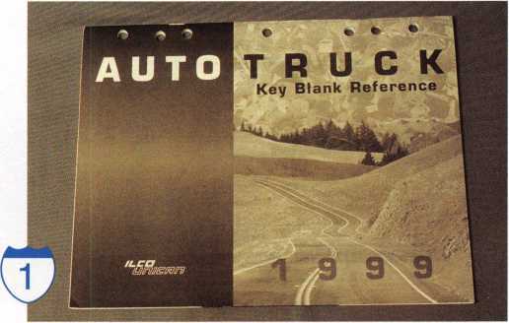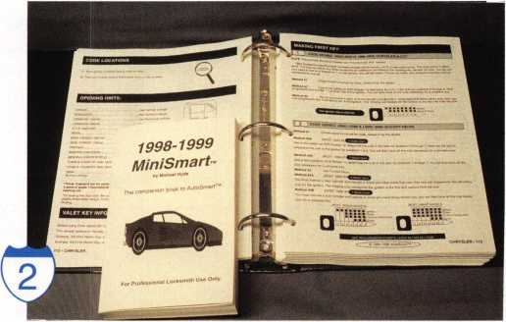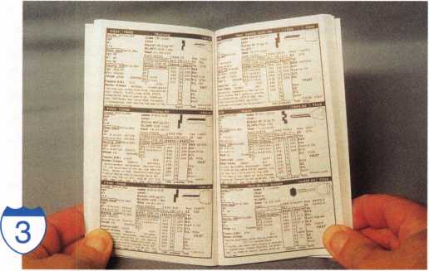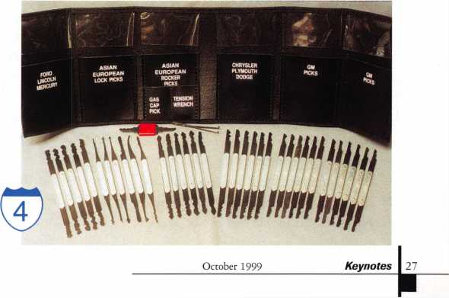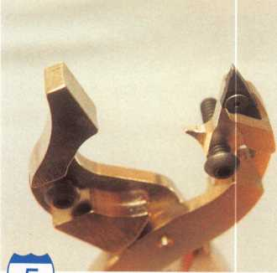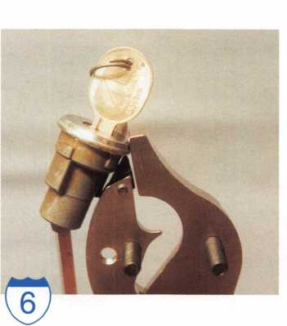

**® Tools and Equipment**

Part of auto lock work involves opening locked vehicles. It would probably be good to own a set of car opening tools. There are quite a few companies that make the tools and the opening instruction books. Like some of the servicing reference books, the opening kits will usually need to be updated each year. The possibility of being called after someone else with tools has already attempted to open a car, suggests some value of lock picking over the use of bypass tools. Most automobiles now have disc tumbler locks on their doors. Although disc tumbler locks tend to be easier to pick than pin tumbler locks, large numbers of double throw tumblers wont necessarily be a piece of cake.

A specialized pick set is available from Lock Technology, Inc. Although some picks in the set look more like standard picks, the majority are double ended rocker picks.

Photo 4 shows them all out and on display. They are made of spring steel and have key bitting type patterns. They are able to simulate a fairly wide variety of key bitting patterns by rocking the picks up and down and repositioning the tumblers. Picks of this sort might be a good backup if you don’t want to put bypass tools in a door where damage has already done or where side impact air bags might raise possible liability problems. They are not magic, but I have found them to be fairly effective on slightly older cars with some wear in the car lock and tumblers. The picks will be generally less effective on newer cars, but you can improve your chances by lubricating the lock.

There is an interesting new tool called the Multi-Purpose Face Cap Tool, from Gator Tools Co. It looks like an odd pair of pliers,

Keynotes October 1999

but it can do some rather important things. The tool is designed to remove auto lock face caps without damage.

The close-up view in photo 5 will give you a better idea how it works. On the left side the jaw has a curved surface, and on the right is a hardened tip. The hardened tip has a slight hook on the end that catches under the lip of the face cap. When the handles of the tool are squeezed together, as shown in photo 6, the hook on the hardened tip pulls the lip slightly outward. The curved end of the jaw follows the curved outside surface of the face cap to minimize the likelihood of damaging or disfiguring the outside surface of the cap. The process is repeated over and over around the circumference of the face cap, in small increments so as not to damage or break the cap. When the lip is pulled outward around the entire cap, the cap will come loose and the lock plug can be removed for decoding or servicing.

When the lock is ready for reassembly, the old cap can be reused. In photo 7, a recess inside the jaws allows the lock (with the cap positioned for re-seating) to be held securely. The two screws (one on each side) can be gradually adjusted downward to bend the lip of the cap over the edge of the lock, until it is seated securely. The screw on one side has two threaded holes to allow you to adjust for different diameter locks and face caps.

Not having a replacement face cap can be the difference between being able to fit a key for a customer’s lock and having to send them to a competitor. The tool isn’t cheap, but it looks fairly sturdy. Savings from not having to stock quantities of every type of face cap under the sun are also a consid­eration. The tool is also designed to be able to stake spring covers, such as those used on

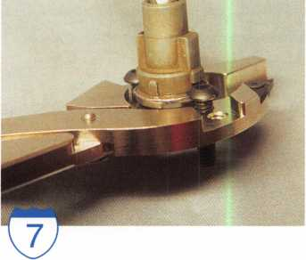

GM sidebar locks. This tool will probably take a bit of practice in order to become proficient, but it could be the only option when correct replacement caps are unavailable.

**<§> Set A Target**

There are many books and tools that would be helpful in extending your auto lock servicing capabilities. Find out what types of service require only labor and know-how, and which ones also require expensive equipment. Then set a target as to how much money you are willing to invest in equipment and supplies, and see where it takes you. You may have to turn down a lot fewer jobs than you thought.

The free literature and catalogs should be available through your locksmith supply company. You can get more information on AutoSmart from Michael Hyde at: National Auto Lock Service, Inc., 738 Kains Ave.,

San Bruno, CA 94066. Phone: 800/954- 5454. Internet address: [www.laserkey.com](http://www.laserkey.com). For information on Fast Facts, contact: Sieveking Products Co., P.O. Box 4287, Rockford, IL 61110. Phone: 815/874-8715.

If your local locksmith supplier doesn’t carry Lock Technology tools and you need more information about the specialty auto lock pick set shown in the article, other similar sets, or other auto related tools, contact: Lock Technology Inc., 552 South Washington Street, Suite 108, Naperville,

IL 60540. Phone: 800/421-7241. For additional information about the Multi-Purpose Face Cap Tool, contact: Steve’s Locksmith Service, 5030 Filarees Circle, Colorado Springs, CO 80917.

Phone: 719/591-8343.

**Your FULL PATS programming**

TOOL IS NOW AVAILABLE !

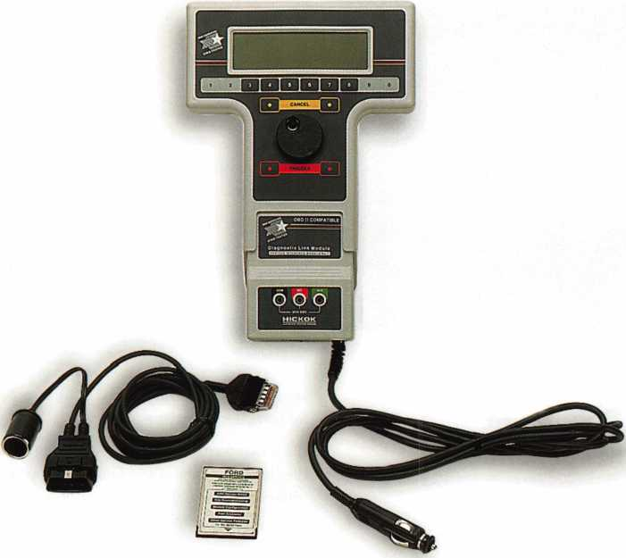

**New Generation STAR (NGS) Tester**

(800-8LA)

* Use the NGS to program keys into Ford-Lincoln-Mercury vehicles (1996 to current model year 2000) equipped with a Passive Anti-Theft System (PATS).
* The NGS kit (Model 800-8LA) contains the components to access all vehicles equipped with PATS.
* Stop sending your customers to the competition, or to the dealer when you can provide the service, make money and save the customer time.

HICKOK

**INCORPORATED**

Contact Hickok Inc. at (800) 342-5080  
for more information on a distributor in your area.

October 1999



column. Bob, however, goes one step further in his explanation and demonstrates the main reason why the VAT system is worthy of its name.

Bob then guides us through the simple and effective systems method to solve this problem, and further explains in simple language the importance the VAT system means to the average car owner.

Section 5 covers the Alpha Tech Column. This column uses an Asian style ignition lock that is not serviceable, and if damaged must be replaced. It also uses a Beretta Column. The 16 photos are clear and easily understood, as to removal technique required for servicing and repair.

Section 6 covers the Beretta Column. If you have ever serviced the Berettas, Corsicas and Grand Prix, you will understand the importance and degree of difficulty in working on this column, the use of serviceable parts, and the costs incurred repairing this column.

Section 7 Covers the MATS/Interlock Column. The MATS (Mechanical Anti-Theft System) is used on the 93-94 Chevy/GMC trucks, vans, and SUVs. The MATS system is made up of an anti-theft ring, an anti-theft collar and a redesigned inner lock housing.

Section 8 covers the Non-Tilt Column.

**GM Steering Column Repair:**

**A Guide for the Locksmith**

By Robert Arthur, 1st Edition, 1999 (The Locksmith Publishing Corp.)

GM Steering Column Repair: A Guide for the Locksmith, was written by Robert Arthur, a locksmith who is the owner of Arthur’s Lock and Key, located in Phoenix, Arizona.

Bob has been a working locksmith for the last seven years, and specializes in GM/Jeep-Chrysler/Nissan automotive theft repairs and VAT systems. In talking with Bob at ALOA ’99 in Cincinnati, Ohio, during the ALOA ACE instructor training course, I was introduced to his newly published book.

His book covers the complete repair and servicing of the General Motors Tilt Column. The GM Tilt Column overhaul in Section 1 (pages 3-13), was clearly outlined in graphic presenta­tion. The presentation of the pictorial demonstration of the uniqueness and intricate details of the GM Tilt Column, explained fully to this reader and student the application techniques needed and necessary to remove parts identified, repair and service the GM Steering Column. The 59 photos of the GM Column were clear and precise, and were presented in a step by step procedure explaining the removal of parts identified, the correct sequence for disassembly of the GM Column. Clearly demonstrated and done in text book fashion. Section 2 covers the servicing of the Inner Lock Housing, (photos 1-13). Section 3 covers the Telescopic Column Service (photos 1-14).

Section 4 covers the GM VATS (Vehicle Anti-Theft System). Except for the difference associated with the unique application of the VAT system, this column is the same as the standard tilt

|

301 KeynotesOctober 1999

Section 9 covers the Modular/Air Bag Column, and explains in detail, and the correct, simple and effective means to remove and service this column. I guess we often wonder why and how the air bag would inflate, the pictures themselves are worth a thousand words.

Section 10 covers the different horn cams, the various locking rings (these are not interchangeable between column types), and the Shaft, and also the Jacket. Lesson one in basic automotive column repair tells us that like the shaft, this part on a steering column is designed as a sleeved in order to collapse upon itself. Remember once this happens, this column needs to be replaced.

The book demonstrates in detail the servicing and repair of the GM Steering Column. Although we assume that the auto mechanic is the technical expert in the servicing and repair of parts related to the automobile or truck/SUV, on the road or in the shop a skilled locksmith can service this particular automotive part and perform simple but effective repair. After all, locksmiths

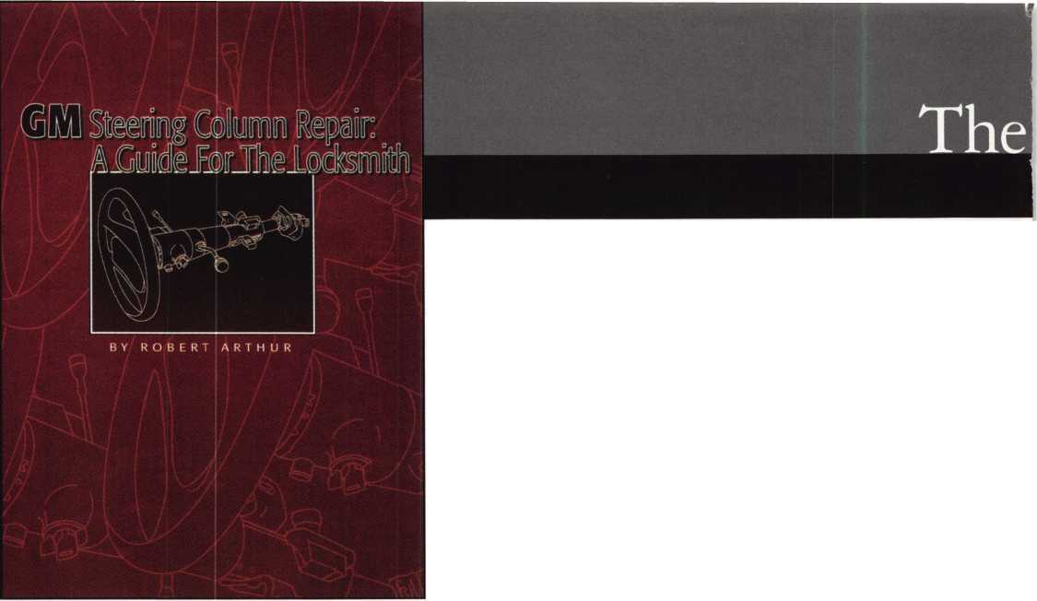

Locksmith Librarian

by Michael A. Ferrill

are frequently questioned as to how they can install alarms without a basic understanding of electricity and a Class D License. That’s surely something to think about if we are to listen to the old school and become complacent in our chosen trade and profession.

Learn and develop those unique gifts, that started you on the journey in this craft, and expanded your knowledge in this profession. The gift that other tradesmen and tradeswomen have shared with us, by the publication of their life’s work.

Robert Arthur took two years to develop this simple but effective book of 52 pages. In less time it took for this reader to perform one standard service call, I have read and acquired the knowledge that will make me become a better locksmith and allow me to understand the use and necessary means to repair GM Steering Columns.

As to the merit of this book, Robert Arthur is a professional and dedicated Locksmith. The fact that he has developed a unique specialty in GM Steering Column Repair, is a plus and clearly demonstrates his additional locksmithing abilities. Now one could say steering column repairs are better left to the automotive technician. I guess that would make sense to the average reader, however if you have a desire to further your technical expertise in several facets of automotive lock repair and servicing of locking systems, then by all means develop this skill. This book should be added to your Library. It can be purchased by writing to: The Locksmith Publishing Corp., 850 Busse Highway, Park Ridge, IL 60068. The cost of the book is: $50.00 (the cost of one service call to the average locksmith).

(Editor’s note: Robert Arthur is an ALOA Certified Instructor and will be teaching GM Steering Column Repair for the ACE program. If you would like to take this class contact ALOA’s Education Manager, David Lowell, CML, CMS at 800.332.2562, or by email at: david@aloa. ioffce. com.)

(

BI/l/D Automotive

Automotive Locks, l\eys, Service Kits, Manuals & Training  
for the Professional Locksmith

When you neeorwf inexpensive VATS Kept JiWuiCefiilied'/AISCel

VAi«mifMWrougHewDrsVAii(sertitica«on training; For a list of BWD VATS Centers and a Seminar Schedule, see offer below.

**FREE!**

1999 **Illustrated Automotive Parts Catalog**

including BWD Service Manual Library Centers,Distributors,

VATS Centers, Seminar Schedule, and more... call

**(800) 647-4926**

or take your web browser to [www.alllock.com](http://www.alllock.com).

WE’RE KEYED TO

YOUR NEEDS

Our brass key blanks are available in all  
popular numbers. Order 1000 - mixed or  
matched. Packed 50 to a box. $102 per  
1000 (Ford $14 per 100) F.O.B. Detroit.  
Prices subject to change.

INSTOCK: **\**

Key Blanks Key Machines Locksmith Tools & Supplies Locks of All Types American & Foreign Automobile Locks Security Hardware (Wholesale Only)

AM1-41C-1041C ~AM3-J41-1046 _AR1-135-1179 AR3-N1179A AR4-135A-1179A J1-98M-1098M ~B2-H98M-H1098M B5-98DB-1098DB B10-H98LA-H1098LA B11-098LA-01098LA _B24-H98X-H1098X B44-X98E-P1098E B45-098H-S1098H B46-X98J-P1098J B47-098K-S1098K J48-P91A-P1098A B49-S91B-S1098B B50-P91C-P1098C B51-S91D-S1098D B52/B4-98X-1098X BE2-A114A-A1114A ,BN1-L54P-K1122D _B01/HL2-22B-R1003M CG1-41G-1041G 'CG2-41GA-1041GA CG4/CG3-41GR-1041GR CG16-41R-1041T CG17/KP1-41Y-1041Y "CG22-41RB-1041E *C01-20-1000* C03-21EB-1001EB C07-21EN-1OO1EN C010-20G-1000G C026-20V-1000V C068-20VS-S1000V _C087-22Z2-1001EH _C088/C066-A22Z2-A1001EH C089-A22GM-A1001ABM C091-A22A1-A1001AH C097-K22-1001GH C0106/HL1-R22B-1003M DE6-54DR-D1054K EA1-61-1014

_EA27\EA50-X61F-X1014F

EL10-C1096CN

ER1-119-1119

ES8-1502 FA1-F54-1054WC FR2-L54G-L1054G "H26-127ES-1127ES ~H27-127DP-1127DP _H50 S27-S1167FD H51-P27-1167FD H54-PS23F3-1184FD H60-1190LN H03-170-1170B _HR1-X61FR-1014C IN1-54F-1054F ~IN3\ IN20-X54K-1054K IN8-L54B-L1054B "IN18-X54F-X1054F IN28-54FN-1054FN "IN29-1054UN IN33-54MT-1054MT JN35-1054DL K2-79HK-1079B KW1-54KS-1176 LI-35-1004 _L4-35A-1004A Ml-92-1092 M2-92B-1092B M4-U92A-1092V M10-92N-1092N M11-92T-1092H M2 7/M 16-92NR-1092NR NA12-174BN-1069LA NA24-1069LC _NA25/NA6-N174D-R1064E NH1-N102-1177N ~RA3-99B-S1970AM RA4-99A-1970AM _R01-62-1069 _R03-174J-1069N RU1-55-1011 "RU4-55P1011P RU16-57PA-A1011P RU45-57-1D-1011D1 "RU46-A57-1D-A1011D1 SI-48-1009

1. 50-1010
2. 050-1010U S6-049KM-N1007KMA _S16-49KM-N1007KMB S22-043LA-01007LA S221/2-43LA-1007LA

"S32-48KMR-N1007RMB

1. 51S-1010N
2. 51SA-L1010N SC1-145-1145 SC4-145A-1145A 'SC6-307A-1307A SC7-145FS-1145F "SC8-145ES-1145E SC9-145E-A1145E SC10-145F-A1145F SC20-145L-A1145L SC22-307W-1307W _SE1-102-1022 _SE8-102AB-1022AB SK1-R21EN-R1001EN T3-111E-1141E

"T7-111GE-1141GE ~WE1-133-1123 WK2-175W-1175N WR3-54WB-1054WB JVR4-54WA-A1054WB ~WR5-54WC-N1054WB WR6/FA2-F54A-A 1054WC ~XL7-XL16-1180S Y1-14-999 Y1E-E14-999N Y2-14A-999A Y3-14YM-C999 Y4-12GM-998 Y6-7X-997X "Y11-7NX-01122 "Y12-07NX-01122A _Y13-R7NX-01122R Y14-R07NX-01122AR 'Y52-7E-997E Y54-07E-0997E Y103-07B-01122B Y149-S19-S1770U ~Y152-PI 9A-P1770U Y220-X14S-999B

STOCKING DISTRIBUTORS FOR:

A-1 Security Mfg.

Abus Lock Co.

Alarm Lock All Lock Co.

American Lock Co.

Arrow Lock

Auto Security Products

B.E. Industries, Inc.

CCL Security Products Detex

Don-Jo Mfg. Co.

EMTEK

ESP Lock Corp.

Fort Lock Corp.

Framon Mfg. Co., Inc.

Harloc HPC, Inc.

Hudson Lock Co.

ILCO Unican Corp.

Keedex

Keystone Novelty Co.

Key Systems KSP

Kwikset Hardware Group LAB

Lori Corp.

Lucky Line Products Corp.

Mag. Engs. & Mfg. Co., Inc. Master Lock Morse Tools Multi Lock, Inc.

S. Parker Hardware Pro-Lok Co.

Quincy Mfg. Co.

Schlage Lock Co.

Silca

STRATTEC

Supra

Trans-Atlantic Co.

Trine Mfg. Co.

Wilson Bohannan Co.



Send in order or

request order  
form.



1-800-445-KEYS (5397)  
313-931-7720

Fax: 1-800-828-KEYS (5397)  
Local Fax: 313-931-7758  
9950 Freeland  
Detroit**,** Michigan 48227

October 1999

Keynotes

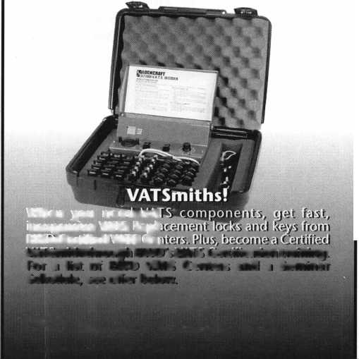

Your Job

Search

BY **CLAIRE L. COHEN, CML**

Perhaps it’s that time, job search time. Its a time of life-altering decisions and a season of reality. Some say, we re experiencing the best economy ever. With your skills, you should have employers knocking down your door. Or should you? You may be able to demand a high salary based on what you know and what you can do. You may be shuffling job offers like a deck of cards.

But it may not be that easy for someone who is looking to enter the security field, the inexperienced locksmith, or an apprentice locksmith. Even in today's good employment market, you still must sell yourself. Your resume (or your employment application) must stand out from the rest. And you must prepare for those interviews. Just how can you become a MASTER of your resume, a MASTER of the interview process and develop into a successful, job­deserving professional?

STEP ONE: The Resume. In today’s fast-paced world, your resume may be submitted as a hard copy or electronically. With electronic resumes, the basics are the same as with hard copy. That infamous one- page piece of paper may seem to take longer to finalize than writing a 20-page paper. Master your resume by spending time to plan it out. There are many references and samples available as models. Think about your resume through the eyes of the potential employer. Why should they consider YOU for this job? What education, job experience, aptitudes, hobbies, etc. allow you to be considered for this job? What makes you different from the rest of the applicants? What makes you uniquely qualified for the position?

Draff your resume. Make your resume clear and concise. Detail pertinent job experience. Summarize your skills and abilities. Include the locksmith-related courses you’ve taken and professional organi­zation membership. Be sure to mention security-related software you have used. Are you a member of ALOA, or a local locksmith association? Do you have a certification?

Have you taken industry-related courses? Enumerate and elaborate. For those who have little industry-related work experience, including volunteer work and part-time jobs emphasizing related skills to the position that you have applied for.

All resumes should, of course, be type­written, on good-quality paper. Employment applications should be filled out in ink, and hand printed or typed. Original copies should be submitted. Ten or 12-point type should be used. Spell-check your resume, and have a friend give it the once-over.

STEP TWO: The Cover Letter. Add a

professional touch to enhancing your resume of application by including a cover letter to the potential employer. In a few short paragraphs mention the position for that you wish to be considered, and summarize some of your experience and/or accomplishments. Be sure to include an address and phone number where you can be reached.

STEP THREE: The Interview Process. There is a lot of anxiety surrounding the ominous day of an interview. You can lessen your anxiety by preparing as you would for a test. Some experts suggest that the best way to prepare for interviews is to practice. Think of questions that the company may ask you and prepare your responses. Plan the key points that you would want to tell the interviewer about yourself.

Don’t forget, you are there to find out if this is the place for you as much as they are there to see if you’re a match for their

opening. Recognize that the interview itself is a two-way street. The company inter­viewing you wants to know about you. Likewise, you want to know about the company where you may be employed. Prior to the interview, you may wish to do some research about the company. Are they growing? Do they have multiple locations? Your questions should focus not only on the position, but also the company. Make a list of questions you have of the company. Questions may include hours, professional advancement, and benefits, etc. You do not come out of an interview thinking of all the questions, you should have asked.

On the day of the interview, arrive on time or slightly early. Dress appropriately. Remember to bring your list of questions, along with a pad of paper and pen for any notes. Although a suit may not be necessary, dress in good taste. Remember to thank your interviewer for taking time to talk to you.

STEP FOUR: The Follow-Up.

Assuming that you feel that this is a job you would like to pursue, write a short thank you letter the day after the interview. Make sure it is short and concise. This should not be a casual note. Even if you think a handwritten letter would be more personal, make sure it still looks like a business letter. You can send an electronic letter if you are sure that person you’re sending it to will think that is appro­priate. In your thank you letter, reiterate your interest in the position and the company.

The thank-you letter confirms your interest and points out what you learned in the interview. For example, if you think after the interview that you would be installing electronic hardware in the job, point out the courses you have taken in access control, this would be an asset for the job.

Mastering these steps will put you closer to your goal of finding a job in the field that you enjoy, where you can grow and develop your skills in our ever-changing security industry.

***Keynotes***

October 1999

**Have a blast.**

Time to gear up for the last safe and vault event of the millennium—SAFETECH 2000! This year promises to be the hottest show ever, with experts on hand to answer questions, give demonstrations, and offer training in every area. With over 24 conveniently scheduled classes, and many exhibitors, SAFETECH 2000 is your source for the information and skills you need to take your career into the next millennium.

While you're there you can also enjoy the city known for its industriousness, as well as good ol' Southern hospitality. Tour the Sloss Furnaces, which earned the town the moniker "Iron City;" visit the Mercedes Benz factory or any of a number of museums; or explore the richly wooded foothills and mysterious caverns of the Appalachian Mountains .

Join us May 1 through 6  
for SAFETECH 2000.

For more information call

214.827.7233,

or visit our website at

[www.savta.org](http://www.savta.org)



SAFETECH2000  
WE'VE GOT THE WORKS

Keynotes

Classified



Dept

**f Classified Advertising Policy**

**Classified advertising space is provided free of charge to ALOA members, and for a fee of $.60 per word, $15 minimum for non-members. Classified ads may be used to advertise used merchandise and overstocked items for sale, “wanted to buy” items, business opportunities, employment opportunities/positions wanted and the like. Members or non-members wishing to advertise services or new merchandise for sale may purchase a “Commercial Classified Ad,” for a fee of $1.30 per word, with a minimum of $40. Each ad will run for two issues. For blind boxes there is a $5 charge to members and non-members. All ads must be submitted in writing to the ALOA office by the fifteenth of the month, two months prior to issue date. Send to Keynotes Classifieds, 3003 Live Oak St, Dallas TX 75204-6186. ALOA reserves the right to refuse any classified advertisement that it deems inappropriate according to the stated purpose of the classified advertising section.**

■ EMPLOYMENT Locksmiths Wanted

10/F/3: Pittsburgh! Pittsburgh! Pittsburgh!

Must have own vehicle and tools. $ 1,000 per week guaranteed!

Call today and ask for Mike:

(800) 926-8881 mdicieco@ inter,statelocksmith. com

Locksmith Wanted

10/F/3: Locksmith wanted in Dayton, Ohio area.

Top notch shop in affluent suburban community. Great sales commissions for right individual. Must be versatile, bondable and reliable. PRP status a plus. Relocation compensation for the right person. Roger Krass P0 Box 0028 Dayton, OH 45441

Locksmith Wanted

10/F/3: Immediate opening for an experienced technician in the “Land of Enchantment,’’ Santa Fe, New Mexico. Requirements include three years minimum experience in areas of master keying, auto lock and general field work. Good driving record essential. Salary $40-$60K plus benefits, including company equipped van and paid vacation after first year. Retirement plan also available. Send or fax resume to:

AB 1 Locksmith Service 1915 Cerillos Road Santa Fe, NM 87505 (505) 983-2690 (505) 983-3022 fax

Commercial Locksmith Wanted

10/F/3: ASAP Opening in Denver for a Commercial Locksmith. Safe and Access Control beneficial. Promotable opportunity. Strong salary, bonus and benefits.

(303) 893-0639fax phyllis@phillips.personnel. com

Sales/Account Executive

10/F/3: We have an immediate opening in our Calgary branch for an experienced sales profes­sional. The successful candidate will possess an excellent knowledge of: high security locks and masterkey theory, all general mechanical and elec­tric door hardware, professional selling techniques to end-users, access control systems, safes and financial institution equipment. In addition, a proven record of sales success is essential. We offer a base salary plus commission along with a full benefit package. Qualified candidates are invited to apply in writing to:

Attention: John Haining, Regional Manager Chubb Lock & Safe 8, 5708-1st Street SE Calgary, AB T2H 2W9 (403) 258-1702 fax

Locksmith Position Opening

10/F/3: The Kenton County Airport Board has an opening in the Building Maintenance Department for a locksmith for second shift (3 pm-1 am) Monday-Thursday. Applicant must have a high school diploma and five years working experience, with complete references available, in the trade of commercial locksmith. Applicant must have the knowledge of the materials, tasks and methods used in commercial locksmithing such as master keying, repair and installation of locksets, hollow metal doors and frames, door closers, panic devices, Simplex com­bination locks, electronic alarms and various other locks associated with locksmithing; the ability to use many locksmith tools; ability to prepare rough sketches of work and estimate of materials and labor; ability to carry out verbal and written directions; ability to work with others. Must be a holder of a valid operators license. Competitive salary and bene­fit package. Apply in person or send resume to: Human Resources Kenton County Airport Board P0 Box 752000 Cincinnati, OH 45275-2000

Locksmith Wanted

10/F/3: Tired of the Rat Race-Here’s the ideal situation for someone who wants to raise a family in the upper Mid-West or seeks a more civilized environment and still make a living comfortably. Established in 1980, we specialize in Commercial and Institutional accounts with CCTV-High Security Locks and Access control Systems. In the heart of Wisconsin with an excellent hospital and one of the nations largest privately owned medical clinics. Downtown walk-in shop location-little competition.

(214)827-1701

Locksmith Wanted

10/F/3: Perfect Opportunity for the right entrepre­neur. Work as a locksmith for the company that could be yours. Original owner plans to sell the business within five years, so you can get to know the business while working. Inside/Outside techni­cian needed with experience in master-keying, interchangeable cores and auto locks. Business established in 1969, consists of highly visible retail location, two well-equipped vans and four full time employees. Located in Queens, New York, we serve many commercial accounts, especially at both airports. Fax letters of interest to:

Eric

(718) 843-1717 fax

Excess Stock For Sale

Large assortment of Schlage Keyblanks, both original and look-alike in these series 35-180, 35-200, 35-100, 35-101, for sale plus an assortment of mis­cellaneous key blanks such as: Chicago, Illinois, Corbin and National (cam lock), ILCO (older auto), Slaymaker and misc (padlock), Yale, Ruswin,

Sargent, Segal, etc. (Cylinder) and many others.

I should have them cataloged soon and will send a list if you are interested. Also available is a Medeco double cylinder deadbolt lock, US 3, 2 3/4" drive in, restricted keyway, PN 11 W 0102 05 G 3-quantity 8 each, $45 each.

Call (505) 528-4106

Locksmith Wanted

10/P/3: Leading Louisville, KY Locksmith Company looking for experience and organiza­tional skills. Offering competitive salary with bonuses, health insurance and profit sharing plan. Call and/or send resume to:

Attention: Bryan Turner

Willis Klein Safe, Lock, Decorative Hardware

4041 Westport Road

Louisville, KY 40207

(800) 928-LOCK

Experienced Locksmith Wanted

9/F/3: Large Lock Shop in the Palm Springs area is looking for an experienced locksmith for field work. Must be proficient in Master Keying, safety deposit boxes and working knowledge of safes. Salary plus commission, health insurance benefits and 40IK plan. Please fax resume to:

(760) 779-1811 or Call (760) 346-5214)

Locksmith Superintindent Wanted

9/F/3: The University of California, Los Angeles is in search of a Locksmith Superintindent. The person will assume full managerial and admini­strative responsibility for the Hardware Shop, Fire Extinguisher Shop and Tool Crib. The individual must also possess the ability to implement state of the art keying systems.

Send resume to:

Ron Guizado

UCLA Campus Human Resources rguizado@chr. ucla. edu (310) 206-1010fax

Experienced Locksmiths Wanted

9/F/3: A family owned business since 1959 is looking for experienced locksmiths. Must be self starters. Will pay portion of relocation. Benefits include-Medical Insurance, two weeks paid vacations, annual sick pay, IRA retirement plan, excellent wages plus commission. Send resume to: Gene Holder

Holders Security Company 7027 E. 40 Th. Street Tulsa, OK 74145 (918) 6663-8660

Keynotes

October 1999

Locksmith Wanted

10/F/3: Chicago area mobile locksmith service seeks an experienced locksmith. Must have own tools and car. Please call:

(708) 456-6198

Security Locksmiths Wanted

9/F/3: If you are a professional Security Locksmith (CML, CPL, CRL, RL), and desire to team up with the best, then JOIN US for a most rewarding career. Our full service commercial security services include Locks, Keys, Safes, Alarms, CCTV and Access Controls. We also provide some residential and automotive work. Ace Lock-Las Vegas is a solid company with an excellent compensation and benefits package for all our team members. Constant training, cross training and upgrading in all skills generates high income and a solid future.

Send or fax resume to:

Harold Ford Ace Lock & Key 1201 S. Casino Center Las Vegas, NV 89104 (702) 382-1754 (702) 382-3963 fax

Qualified Apprentice Needed

9/F/3: If you have some training as a locksmith and are willing to work hard and learn fast; and if you desire to team up with the best, then a rewarding career awaits you. We are a full service commercial security service (Locks, Keys, Safes, Alarms, CCTV and Access Controls), over 30 years in Las Vegas. We offer our full time employees an excellent compensation and benefits package, including retirement plan. Under constant training, cross training and upgrading in all skills, high incomes are common and a solid future assured. A drug test and a criminal background investigation will be required. Initial training begins in the shop, assisting a team of professionals and learning all areas of general locksmithing. Send or fax resume to:

Harold Ford Ace Lock & Key 1201 S. Casino Center Las Vegas, NV 89104 (702) 382-3963 fax

Locksmiths Wanted

9/F/3: Two locksmiths wanted to fill positions in Missoula, Mont. We need an outside and an inside service representative. We have two vans and a storefront. Prefer two years of experience and must be willing to relocate. Salary DOE plus commission possible, paid vacation and the opportunity for advancement.

Call Peter:

(406) 542-2472 (406) 542-3221 fax

Experienced Service Technician Wanted

9/F/2: Experienced Service Technician sought in established company in central Illinois. Must be neat in appearance with good work habits. Good driving record a must. Our company offers a good salary with an excellent benefit package-many Extras.

Send resume or contact:

Denny, Dave & Harry Locksmiths Inc.

116 E. University Ave.

Champaign, II61820 (217) 352-5034 (217) 352-3505 fax

Senior Account Manager Wanted

9/F/3: A leading company in the high security locks industry is looking for a professional sales manager with strong organization skills to fill a senior account manager position in the Los Angeles area, must have five years experience in the locksmith industry.

Please call Ron (evenings):

(310) 260-9760

Inside Sales Representative Wanted

9/F/3: Jo-Van Distributors Inc., a leading regional distributor of locksmith supplies and security hardware located in Toronto, has openings for inside sales personnel. Prerequisites include excellent organization and communication skills and trade related experience.

(416) 752-7282 fax

Looking For A Position

9/F/3: Institutional locksmith looking for a position. CML, in Northeast area, 22 years institutional and commercial experience, networking for career opportunity with manufacturer, distributor or institutional position. Strong teaching and technical skills. Willing to relocate for the right opportunity. Resume furnished on request.

Call: (800) 532-2562 (214) 827-1810fax

Locksmith Position Wanted

9/F/3:1 am a locksmith with 11 years of experience who recently relocated to the Salem, Ore. area and I am looking for a locksmith position. I am an expert at safe-opening and I own all of my tools. For the last 11 years I worked for VSR Inc in Las Vegas; and I was the manager for the last three. I am ready to work when the opportunity presents itself.

Please call Bryan:

(503) 364-5135

■ BUSINESSES FOR SALE Business For Sale

9/F/3: A well established, 18 years, locksmith business on a major road in Baltimore County, Maryland is for sale. Customer base includes commercial, government, automotive, auto dealers, residential and walk-in trade. Main building has a retail area, workshop area, office space and storage area on second floor. Garage building has a two bay service area. Excellent growth potential for aggressive owner. Last years gross sales were $217,000. Asking $198,000. Inquire for a list of equipment included.

Locksmith

PO Box 19018

Baltimore, MD 21284-9018

Locksmith Shop For Sale

9/F/3: Full service locksmith shop in Southern California serving the Beaumont/Banning area for over 26 years is for sale. Includes equipment, inventory, commercial accounts and a 1984 1/2 ton Ford van. 1800 sq. feet building also available for lease or sale. Owner can stay on for transition. Call weekdays for details or leave message:

(909) 845-5397

Master Locksmith Business For Sale

9/P/3: Located in East Yorkshire, England. Established for 20 years. Excellent financial track record with a large number of regular and consistent customers. Showroom, workshop, offices and trained MLA locksmiths. Available due to early retirement reasons only. Send all inquiries to:

Gamess Jones 732A Anlaby Road Hull HU4 6BP England

■ WANTED TO BUY/SELL For Sale or Trade

10/P/2: For sale or trade, door closer service equipment and parts in LCN, Corbin, Russwin, Yale, Norton and Lockwood for $1500. Contact: **Bryan**

Willis Klein Safe, Lock, Decorative Hardware (800) 928-LOCK

Tiyout Keys, Depth Keys For Sale

10/P/2: Aero Lock does not use key duplicator machines to produce its tryout keys or depth keys. Only original computer controlled code cut. Buy the best.

Aero Lock

3675 New Getwell Road **#9** Memphis, TN 38118 (800) 627-9433; (901) 362-1197 fax aerolock@ix. netcom. com httpill[www.aerolock](http://www.aerolock). com

Wanted To Buy/Sale

10/F/2: Locksmtih tools and more for sale. Locksmith tools, supplies, machines, auto code cutters, code books and safe tools. Depth key sets and over 10,000 auto and domestic key blanks. Call for prices.

Emmet W. Sapp (916) 391-7052

Locks For Sale

10/F/2: Marks Mortise Handle Sets 625, Schlage D & L series, Schlage F51PD Clairmont 616, Sargent Rim & KIK cylinders , Sargent Locksets, Yale Locksets, Yale Rim and KIK cylinders, Medeco cylinders Commerical 00 keyway,

Medeco cylinders SKY 04 keyway, Medeco cylinders GLD Biaxial, Dexter Locksets, and Von Duprin 88EO x626. All locks are new w/ assorted keyways and finishes. If interested please call for quantity and prices.

Jennifer Renderer (305) 944-0469

Wanted To Sell

9/F/3: Retired locksmith has several items for sale. Miles Osborne Safe $40. Lockmasters Cutaway Lock For Manipulation, all metal mount $40. Back issues of Locksmith Ledger and National Locksmith and other items for list.

Locksmith

45055 East Florida #8 Hemet, CA 92544

Sets For Sale

9/F/3: LTI Rocker pick sets, LT340A Auto set and LT 280 GM set. Never used with instructions.

$75 for both, includes shipping.

CallJohn:

(203) 397-3093

Locksmith Tools and More For Sale

9/P/2: Locksmith tools, supplies, machines, two Curtis Automotive Code Cutters, Code books and safe tools. Depth key sets and over 5,000 automotive and domestic keys. $18,500 firm. **Contact:**

John M. Merry P.O. Box 728 Dereby, NY 14047-0728 (716) 549-5439

October 1999

***Keynotes*** in

Associate

Members



|  |  |
| --- | --- |
| Manufacturers | Arrow Lock Company  10300 Foster Avenue  Brooklyn, NY 11236 (718) 257-4700; FAX (718) 649-9097 |
|  | • • • • |
| A & B Safe Corp.  171 S. Delsea Dr.  Glassboro, NJ 08028 (800) 253-1267; FAX (609) 863-1208 | Auto Security Products (A. S. P.)  P.0. Box 10  Redmond, WA 98073-0010 (425) 556-1900; FAX (425) 558-1205 |
| • • # • | • e |
| ASSA Inc.  10300 Foster Ave.  Brooklyn, NY 11236 (800} 235-7482; FAX (718) 257-2772 | BWD Automotive  900 Ravenwood Dr.  Selma, AL 36701  (334) 874-9001; FAX (334) 874-6011 |
| • | • • |
| Abus Lock Company  3555 Holly Lane North  Plymouth, MN 55447-0507 (800) 352-2287; FAX (612) 509-9939 | Chicago Lock Company  10100 88th Ave.  Pleasant Prairie, Wl 53158-0069 (800) 445-3204; FAX (414) 947-7178 |
| • | • |
| Adams Rite Manufacturing Co.  P.0. Box 1301  LaPuente,CA 91749-1301 (562) 699-0511; FAX (562) 699-5094 | Corbin Russwin Architectural Hardware  P.0. Box 25288  Charlotte, NC 28229 (800) 543-3658; FAX (800) 447-6714 |
| • • • • | • ••• |
| Adesco Safe Manufacturing Co.  web: [www.adesco.com](http://www.adesco.com) email: [sales@adesco.com](mailto:sales@adesco.com) (800) 821-6803; FAX (562) 408-6427 | Curtis Industries  6140 Parkland Blvd, Ste. 300  Mayfield Heights, OH 44124-4103 (800) 555-5397 |
| • | • • |
| Adrian Steel Company  web: [www.adriansteel.com](http://www.adriansteel.com)  Adrian, Ml 49221  (800) 677-2726; FAX (517) 265-5834 | DETEX  302 Detex Dr.  New Braunfels, TX 78130 (800) 729-3839; FAX (830) 620-6711 |
| • | • • • • |
| Alarm Lock Systems, Inc.  345 Bayview Ave.  Amityville, NY 11701 (800) ALA-LOCK; (516) 789-3383 | Don-Jo Manufacturing, Inc.  P.O. Box 929  Sterling, MA 01564 (508)422-3377; FAX (508) 422-3467 |
| e | • e |
| Aiphone Intercom Systems  1700-130th Avenue, NE  Bellevue, WA 98005 (425) 455-0510; FAX (425) 455-0071 | Door Controls International  2362 Bishop Circle East  Dexter, Ml 48130  (800)742-3634; FAX (800) 742-0410 |
| • • • | • • • • |
| American Lock Co.  3400 West Exchange Road  Crete, IL 60417-2099 (708) 534-2000; FAX (708) 534-0531 | ESP Lock Products, Inc.  375 Harvard Street  Leominster, MA 01453 (978)537-6121; FAX (978) 534-9109 |
| e • | e • |
| American Security Products (AMSEC)  11925 Pacific Ave.  Fontana, CA 92337-6963 (800) 423-1881; FAX (909)685-9685 | Folger Adam Security, Inc.  16300 W. 103rd Street  Lemont, IL 60439  (630) 739-3900; FAX (630) 739-6138 |
| • • | • « |
|  |  |

Associate members of the Associated Locksmiths of America (ALO A) manufacture or distribute materials or equipment, or provide services, for the security industry. Many have donated money, services and equipment to ALGA in addition to their annual dues. Their support of ALOA projects enhances overall membership benefits and we encourage our members to patronize these firms. If you know of a potential candidate for associate membership, please contact the ALO A Membership staff at (800) 532-ALO A. Associate member dues are $500 per year and entitle the payor to use the ALOA logo, and selected discounts on ALOA products and services.

Legend

Personal, vehicle, electronic, fire, burglar, and exit

9 Automotive: Lockout equipment, key chains/rings

9 Builders Hardware: Door closers, fumiture/decorative hardware, viewers, emergency exit devices

Books, reference guides, publications, computer software

9 CCTV/Photo Imaging: Cameras, monitors, photo ID equipment, cables

access control and readers, surveil­lance, electric/magnetic locks and strikes, keypads

9 Lock Devices: Auto locks, cylinders, emergency exit/entrance control, locks (various types), strikes

Tools & Supplies: Key blanks, cutters, picks, rings/hooks, custom van/truck supplies



**361 *Keynotes***

October 1999

|  |  |  |
| --- | --- | --- |
| Fort Lock Corp.  3000 N. River Rd.  River Grove, IL 60171 (708) 456-1100; FAX (708) 456-9476 | LCN Closers (Division of Ingersol)  121 W. Railroad Ave.  Princeton, IL 61356 (815) 875-3311; FAX (815) 875-3222 | STRATTEC Security Corp.  3333 W. Good Hope Rd.  Milwaukee, Wl 53209 (414) 247-3333; FAX (414) 247-3329 |
| • ••••• | • | • • • |
| Grobet File Co. of America  750 Washington Ave.  Carlstadt, NJ 07072 (800) 962-7242; FAX (800) 243-2432 | La Gard, Inc.  3330 Kashiwa Street  Torrance, CA 90505 (310) 325-5670; FAX (310) 325-5615 | Sargent & Greenleaf, Inc.  P.O. Box 930  Nicholasville, KY 40340-0930 (606) 885-9411; FAX (606) 887-2057 |
| § | • • • | • • • • |
| H.E.S., Inc.  2040 W. Quail Ave.  Phoenix, AZ 85027 (602) 582-4626; FAX (602) 582-4641 | Lucky Line Products  7890 Dunbrook Rd.  San Diego, CA 92126 (619) 549-6699; FAX (619) 549-0949 | Schlage Lock Co.  1915 Jamboree Suite 165  Colorado Springs, CO 80920 (800) 847-1864; FAX (800) 452-0663 |
| • • • | • | • • |
| HPC, Inc.  3999 N. 25th Avenue  Schiller Park, IL 60176 (847) 671-6280; FAX (847) 671-6343 | M.A.G. Engineering & Mfg. Inc.  15261 Transistor Lane  Huntington Beach, CA 92649 (714) 891-5100; FAX (714) 892-6845 | Schwab Corporation  110 Professional Court  Lafayette, IN 47905 (765) 447-9470; FAX (765) 447-8278 |
| • • • | • • • | • |
| HID Corporation  9292 Jeronimo Road  Irvine, CA 92618  (949) 568-1600; FAX (949) 568-1680 | MARKS USA  5300 New Horizons Blvd.  Amityville, NY 11701 (516) 225-5400; FAX (516) 225-6136 | Securitron Magnalock Corp.  550 Vista Blvd.  Sparks, NV 89434  (800) 624-5625; FAX (702) 355-5636 |
| • • | • | • • |
| Hongtai Lock Co. Ltd.  Jidong, Xiaolan Road, Xiolan Zhongshan/Guangdong, China 528415 (86) 137-238-1414; FAX (86) 208-793-3856 | MUL-T-LOCK USA, Inc.  300-1 Route 17 South Suite A  Lodi, NJ 07644  (800) 562-3511; FAX (973) 778-4007 | Security Door Controls  3580 Willow Lane  Westlake Village, CA 91361 (805) 494-0622; FAX (800) 959-4732 |
| • • • • | • • • | • |
| llco Unican  400 Jeffreys Road  Rocky Mount NC 27804 (252) 446-3321; FAX (252) 446-4702 | Master Lock Company  2600 North 32nd Street  Milwaukee, Wl 53211 (414) 444-2800; FAX (414) 449-3114 | Security Solutions  1640 W. Hwy. 152  Mustang, OK 73064 (405) 376-1600; FAX (405) 376-6870 |
| ••••••• | © • | • • • |
| In Out Systems, Inc.  3650-B Matte Boulevard  Brassard, Quebec J4Y-2Z2, Canada (450) 444-5949; FAX (450) 444-4856 | Medeco Security Locks  P.O. Box 3075  Salem, VA 24153  (540)380-5000; FAX (540) 380-5010 | Sentry Group  900 Linden Ave.  Rochester, NY 14625-2784 (716) 381-4900; FAX (716) 381-8559 |
| 0 • | • • • | • |
| Intellikey  551 S. Apolo Boulevard, Suite 204  Melbourne, Florida 32901 (800) 226-0703; FAX (407) 724-0811 | Meilink Safe Company  111 Security Parkway  New Albany, IN 47150 (800) 634-5465; FAX (800) 896-6606 | Sully Tools Inc.  3515 Nodding Pine Ct  Fairfax, VA 22033  (703) 689-3416; FAX (703) 787-0869 |
|  | • | • • • |
| KABA High Security Locks  P.O. Box 490  Southington, CT 06489 (860) 621-3601; FAX (860) 621-9727 | National Cabinet Lock  200 Old Mill Road, P. 0. Box 200  Mauldin, SC 29662 (864) 297-6655; FAX (864) 297-9987 | Taymor Industries, Inc.  1586 Zephyr Ave.  Hayward, CA 94544 (800) 388-9887; FAX (800) 288-8133 |
| • | • | • • |
| KEY-BAK; Div. of W. Coast Chain Mfg. Co.  1460 S. Balboa Ave.  Ontario, CA 91762 (909) 923-7800; FAX (909) 923-0024 | Newman Tonks  805 N Buckman St  Shepardsville, KY 40165 (800) 826-5792; FAX (800) 777-8229 | Trine Products Corporation  1430 Ferris Place  Bronx, NY 10461  (718) 829-4796; FAX (718) 792-9127 |
| • • • • | • • | • • • |
| Knaack Manufacturing Co.  420 E. Terra Cotta Ave.  Crystal Lake, IL 60014 (800) 456-7865; FAX (815) 459-9097 | ROFU International Corp.  2004-B 48th Ave.; Court E  Tacoma, WA 98424 (800) 255-7638; FAX (253) 922-1728 | Videx, Inc.  1105 NE Circle Blvd.  Corvallis, OR 97330 (541) 758-0521; FAX (541) 752-5285 |
| • | • • • | • • • |
| LAB Security  700 Emmett St  Bristol, CT 06010  (800) 243-8242; FAX (203) 583-7838 | Rutherford Controls Inc.  2697 International Pkwy, Bid 5 #100  Virginia Beach, VA 23452 (757) 427-1230; FAX (757) 427-9549 | W-Lok Corporation  675 East 16th Street, Suite 111  Holland, Ml 49423 (616) 355-4015; FAX (616) 355-4295 |
| • | © | • |
|  |  |  |

October 1999

Keynotes

|  |  |  |
| --- | --- | --- |
| Weiser Lock Company  6700 Weiser Lock Blvd.  Tucson, AZ 85746  (502) 741-6338; FAX (520) 741-6363  • • | Clark Security Products, Inc.  4775 Viewridge Ave.  San Diego, CA 92123-1641 (800) 854-2088; FAX (619) 974-5284 | HS&S Wholesale Distributors  12915 West 8 Mile Road  Detroit Ml 48235  (800) 521-2202; FAX (313) 342-7580  ^ ® ® <0 ® ® |
| Wilson Bohannan Company  621 Buckeye Street  Marion, OH 43301-0504 (800) 382-3639; FAX (740) 383-1653  • | Cook’s Building Specialties  2441 Menaul Blvd. NE; P.O. Box 37320 Albuquerque, NM 87176-7320 (505)883-5701; FAX (505) 883-5704  •••••• | Hans Johnsen Company  8901 Chancellor Row  Dallas, TX 75247  (214) 879-1550; FAX (214) 879-1530  •••••••• |
| Yale Security Inc.  P.O. Box 25288  Charlotte, NC 28229-8010 (800) 438-1951; FAX (800) 338-0965  • • • • | DiMark International  3117 Liberator St, Unit A  Santa Maria, CA 93455 (800) 235-2435; FAX (805) 928-8034  (Q m | Hardware Agencies, Ltd.  1220 Dundas Street East  Toronto, ON M4M 1S3 (416) 462-1921; FAX (414) 462-1922 |
| Zhongshan Hua Feng Lock Products  S Yongning Industrial Road, Ziaolan Zhongshan Guangdong, China  86-760 227 82 63; FAX 86-270 227 80 63  e | Dire’s Lock & Key Co.  2201 Broadway  Denver, CO 80205  (303) 294-0176; FAX (303) 294-0198  •••§••••••• | Hardware Suppliers of America  P.O. Box 2208  Winterville, NC 28590 (800) 334-5625; FAX (800) 334-5635  • • |
| Distributors | Direct Security Supply, Inc.  36 Lincoln Street  Boston, MA 02135 (800) 252-5757; FAX (800) 452-8600  ^ <|J} @ (|^ (p ^ | IDN, Inc.  1000 S. Main, Suite 280  Grapevine, TX 76051 (817)421-5470; FAX (817) 421-5468 |
| Accredited Lock Supply Co.  P.O. Box 1442  Secaucus, NJ 07096-1442 (800) 652-2835; FAX (201) 865-5031  ••••••• | Doyle Lock Supply  2211 W. River Road N.  Minneapolis, MN 55411 (800) 333-6953; FAX (612) 521-0166  ••••••••••• | Intermountain Lock & Supply Co  3106 South Main Street  Salt Lake City, Utah 84115 (800) 453-5386; FAX (801) 485-7205  •••••••••• |
| Ace Lock & Security Supply Co.  565 Rahway Ave.  Union, NJ 07083-6631 (800) ACE-LOCK; (800) ACE-FAX4  •••••••• | Dugmore & Duncan Inc.  30 Pond Park Rd.  Hingham, MA 02043 (888) 384-6673; FAX (888) 329-3846  ••••••• | JLM Wholesale, Inc.  3095 Mullins Ct  Oxford, Ml 48371-1643 (800) 522-2940; FAX (800) 782-1160  • • • |
| ADI  263 Old Country Road  Melville, NY 11747 (516) 692-1000; FAX (516) 692-3457  • • • | E. L. Reinhardt Co., Inc.  3250 Fanum Road  Vadnais Heights, MN 55110 (800)328-1311; FAX (612) 481-0166  •••••• | Jo-Van Distributors Inc.  929 Warden Ave.  Scarborough, Ontario MIL 4C6 (416) 752-7249; FAX (416) 752-3845  ••••••••••• |
| Akron Hardware Consultants, Inc.  2579 South Arlington Road  Akron, OH 44319  (800) 321-9602; FAX (800) 328-6070  • • • | Ewert Wholesale Hardware  4709 W 120th St  Alsip II 60658  (800) 451-0200; FAX (708) 597-0881  ^ (0 (Q ^ | Lockmasters, Inc.  5085 Danville Road  Nicholasville KY, 40356 (800) 654-0637; FAX (606) 885-7093  • • • • |
| American Security Distribution  4411 E. La Palma  Anaheim, CA 92807 (714)996-0791; FAX (714) 579-3508  ••••••• | Fairway Supply, Inc.  2631 Lombardy Lane  Dallas, TX 75220  (214)350-0021; FAX (214) 352-4299  ••••••• | Locks Company  2050 N.E. 151 St.  N. Miami, FL 33162 (800) 288-0801; FAX (305) 949-3619  ^ @ (0 <j^ ($ ^ |
| Andrews Wholesale Lock Supply  544 S. 9th St.  Lebanon, PA 17042-6608 (717) 272-7422; FAX (717) 274-8679  • | Foley-Belsaw Company  6301 Equitable Road  Kansas City, MO 64120 (800) 821-3452; FAX (816) 483-5010  (|^ (Q 0 | The Locksmith Store Inc.  1229 E Algonquin Rd. Suite E  Arlington Heights, IL 60005 (847) 364-5111; FAX (847) 364-5125  • • • • |
| Boyle & Chase Inc.  P. 0. Box 74  Accord, MA 02018-0074 (800) 325-2530; FAX (800) 205-3500  • 01 | Fried Brothers, Inc.  467 N. 7th St.  Philadelphia, PA 19123 (800) 523-2924; FAX (800) 541-3489 | M. Zion Company  69 Reade Street 4th Floor  New York, NY 10007 (212) 349-8677; FAX (212) 964-0495  ••••••• |
|  |  |  |
| 9 Alarms 9 Business/Tech & Ed. 9 Tools & Supplies  9 Bank Security Equipment 9 CCTV/Photo Imaging 9 Safes/Vaults  9 Automotive 9 Electric/Electronic Security 9 Other  9 Builders Hardware 9 Lock Devices | | |

***Keynotes***

October 1999

|  |  |
| --- | --- |
| McDonald-DASH Locksmith Supply  5767 E. Shelby Dr.  Memphis, TN 38141 (800) 238-7541; FAX (901) 366-0005 | Turn 10  P. 0. Box 746  Marietta, OH m45750 (800) 848-9790; FAX (800) 391-4553 |
| •••••••• | ^ |
| McManus Locksmith Supply, inc.  P.O. Box 9231,1309 Central Ave.  Charlotte, NC 28299 (702) 333-9112; FAX (704) 332-8664 | U.S. Lock Corporation  77 Rodeo Drive  Brentwood, NY 11717 (800) 925-5000; FAX (800) 338-5625 |
| •••••• | • • • • • |
| McMaster-Carr Supply Company  600 County Line Rd,  Elmhurst, IL 60126-2081 (630) 833-0300; FAX (630) 834-9427 | Webster Safe & Lock Company, Inc.  3020 Millbranch  Memphis, TN 38116 (901) 332-2911; FAX (901) 332-2878 |
| •••••• | ••••••• |
| Monaco Lock Co.  339-345 Newark Ave.  Jersey City, NJ 07302 (800) 526-6094; FAX (800) 845-LOCK | Service |
| no# |  |
| Securite.com  4775 Viewridge Avenue  San Diego, CA 92123 (800) 241-3930; FAX (619) 974-5269 | Alarm Monitoring Service, Inc.  5021 Fairfield St.  Metairie, LA 70006 (504) 454-2163; (504) 456-8737 |
| • • • | • |
| Omaha Wholesale Hardware  1201 Pacific Street, PO Box 3628  Omaha, NE 68108 (800) 238-4566 | Allstate Insurance Company  2775 Sanders Road, Suite A5  Northbrook, IL 60062 (847) 402-8196; FAX(847) 326-7509 |
| •••••••• | • |
| Security Lock Distributors  40 A Street  Needham Heights, MA 02194 (800) 847-5625; FAX (800) 878-6400 | Diamond Software  2952 N. Expressway  Griffin, GA 30223  (770) 227-7650; FAX (770) 227-1699 |
| • • • | • |
| Sentry Security Fasteners  8109 N. University  Peoria, IL 61615  (309) 693-2800; FAX (309) 693-2872 | Locksmith Publishing Corp.  850 Busse Hwy.  Park Ridge, IL 60068 (847) 692-5940; FAX (847)692-4604 |
| # * | • |
| Southern Lock and Supply Co.  Box 1980,10910 Endeavor Way  Pinellas Park, FL 33780 (800) 237-2875; FAX: (800) 447-2299 | The National Locksmith Magazine  1533 Burgundy Parkway  Streamwood, IL 60107 (630) 837-2044; FAX (630) 837-1210 |
| ••••••••• | • |
| Stone & Berg Wholesale  99 Stafford Street  Worcester, MA 01603 (800) 225-7405; FAX (800) 535-5625 | Pine Technical College  1000 4th Street  Pine City, MN 55063 (800)521-7463; FAX (320) 629-7603 |
| •••••••••• | • |
| Strauss Safe & Lock Company  1801 Second Avenue  Des Moines, IA 50314 (515)288-9571; FAX: (515)288-9752 |  |
| •••••• |  |
| Timemaster, Inc.  127 SE 29th Street  Topeka, KS 66605  (785) 232-8705; FAX (800) 798-8463 |  |
| ••••••• |  |
| Top Notch Distributors, Inc.  3151 Goni Rd.  Carson City, NV 89706-7922 (800) 722-4210; FAX (800) 248-3620 |  |
| • M |  |
|  |  |

It pays

to have new faces  
in the crowd.



During 1999  
each ALOA member  
who sponsors  
a new applicant  
will receive $40 in  
Convention Bucks  
(upon clearance,  
and payment of  
application fee and dues).

***Keynotes***



October 1999

VISA

^ATM

DIBIT

CARD



Diners Club International‘

Accept Credit Cards  
and Increase Sales and Profits  
by 30% - 50%

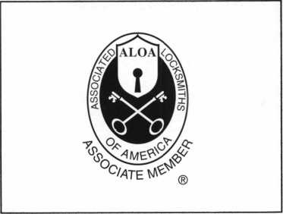

There are three reasons why people don’t accept credit cards:

Through Association Benefits ^ 1. Too expensive.

These Concerns Are Eliminated 2. The paperwork hassle.

3. Inability to qualify.

Here’s how it works:

* Simply swipe or enter the credit card #.
* Enter amount of sale. \« Hassle - VAISY Qualifying
* Approval within seconds.
* Funds wired electronically into your local checking account within 48 hours.

Receive a

Because of your association membership, nearly 100% of all retail and home based applicants

will be approved even with past credit problems.

Currently Processing Merchants Please Read

Monthly Lease To Own Set-Up Options

Special Low Discount Rate and Transaction Fee: 1.59% + 201

Plus Monthly Statement/Customer Service Fee: $10

Package A: $29.95 Terminal

Package B: $39.95 Terminal & Printer In One

Deluxe Package C: $49.95 Portable Terminal/Ptinter/Pin Pad  
Debit acess fee Ability to Accept Visa/MC “Check Cards”

$ 10/mo. & ATM Cards at a FLAT 250

Totally Eliminating the 1.59 % Rate  
(All lease terms 48 months • Monthly minimum $25)

] I authorize Universal’s sales office to print and deposit a check

in the amount of $49 (normally $ 125) for my application fee which  
covers initial materials, application processing, equipment warranty,

shipping & handling, programming, installation and training.

* Fill out a check, tape here above mini form and then fax.

Fax Express Mini Form Now To 1-800-439-7773

every.

I •

,?Pyour

YOU

O',

ca,tf rate

to

Company Name. Contact Name _

Address. City

State.

Zip.

Phone

Best Time

Signature.

New Account Set-up Options (Check)

Package A □

Package B □

Deluxe Package C I—I

Free Pin Pad Program For Currently Processing Merchants □

A subsidiary of Universal Savings Bank, FA.

Marketing Office 1-800-836-4295

Universal Payment Processing Provides 24 Hour Live Customer Service.



T

Legislative Update

by Tim McMullen

ALOA SCORES NUMEROUS SUCCESSES THIS YEAR—

AT A PRICE

f you’ve been reading Legislative Update over the last nine months, you will know that many legislative battles have been won this year, but the war is far from over. In Arizona, we came very close to passing a bill that would have defined our profession in the Code, and put into place ALOA’s Positive ID Policy, thereby protecting locksmiths. In North Carolina and Connecticut, we also kept alive licensing bills that are extremely fair. In Indiana, Missouri and Iowa, we were able to put the brakes on some harmful alarm legislation. Texas declared a victory, and Louisiana could have turned out much worse. We’ve made a full-frontal assault on the U.S. Postmaster General to get the government to enforce their own mail-order lockpicking law, and filed amicus briefs to the Illinois General Attorney on why retail stores need to be licensed. We’re now actively combining forces in Ohio to deal with alarm legislation being introduced. We’ve hosted roundtable discussions at convention where ALOA chapters and other locksmith associations exchanged ideas and brought each other up-to-date on the latest legislative battles in their states.

But all these battles came at a price, and now we’re asking for you to make an investment in your future. In the next few weeks, you will be receiving a letter asking for a donation for ALOA’s continuing work in legislative affairs on behalf of all locksmiths. Please consider it carefully.

Why does ALOA need money for legislative affairs? Last year, ALOA conducted a survey asking, “Do you feel it is ALOA’s

responsibility to protect the locksmith industry from objection­able legislation?” 75% answered a resounding “YES!” When asked “How important is it for ALOA to actively oppose unfavorable legislation on the state and national levels?” 75% said that it was “Very important.” When asked, “How important is it for ALOA to actively promote practical locksmithing legislation?” 63% said it was also “Very important.”

In that same survey, when asked “What percentage of your dues should go to this cause?” The percentage cited most often was 25%. The reality is only about 8% of your dues goes toward legislative affairs. At the national level, NBFAA spends 13% on legislative affairs. However, NBFAA works primarily at the direction of its state organizations. These state chapters raise money and hire lobbyists to do one thing: get their legislation passed - no matter what the cost. At $1000 to $2000 a month, these lobbyists are determined to do just that. As we become more involved, the more battles and the more lobbyists we will have to face.

How much does it cost to run a grass-roots lobbying campaign? Plenty. What we don’t pay a lobbyist is more than made up for in coordinating mass mailings, staffing phone banks and monitoring legislation on a day-to-day basis. As you can see ALOA is working hard for your interests at the state level. Ensuring your success is why we’re so involved. Please take the time to contribute what you can, because none of us thrive unless all of us survive.

If you would like to make a contribution now, please tear off the bottom form and mail it in today!

YES! I support ALOA in its fight against legistlation that is bad for locksmiting—bad for my business!

Enclosed is my donation in the amount of: d] $25 d] $35 dd $50 d] $75 dl $100 I I Other $

Indicate type of funds:’ dl MasterCard dl Visa dl American Express dl Check dl Money Order

Credit Card Number: Expiration Date:/

Name (as it appears on card):

Signature:

d] Please use my donation in my state ofexclusively.

Federal law mandates that political donations are not tax deductible.

Please make checks payable to “ALOA LEGISLATIVE FUND.”

E>3 Mail this completed form with your donation to:

LEGISLATIVE ACTION NETWORK, Associated Locksmiths of America, 3003 Live Oak Street, Dallas, TX 75204.

October 1999 Keynotes

WE INVITE YOUR INQUIRIES

GOLDEN GATE SCHOOL OF LOCK TECHNOLOGY

l V" 3722 San Pablo Ave., Dept. A \ Oakland, CA 94608

V"" Phone (510) 654-9425

* Fax (510) 654-9429

*EARN* ***$200,000*** OR MORE PER YEAR!

START YOUR OWN RESIDENT LOCKSMITH SCHOOL

Let me show you how to make a substantial above-average income by training men and women to become professional locksmiths.

We offer Administrative, Marketing, and Instructional assistance to ensure your complete understanding of how to start and maintain a profitable "Hands-on Locksmith School.

Included with the information are comprehensive lesson plans and instructional video's that thoroughly detail every aspect of locksmith training.

800 LOCKSMITH ALOA 2000

BWD

Golden Gate Key Hickok Inc.

Jet Hardware

Key Sales

Locksmith Ledger, Mitchell Industries

SAFETECH 2000

Security Lock Timemaster

Yankee Security

*Keynotes Advi*

Advertiser

Keynotes

Authors

Dept



1 Claire L. Cohen, the second woman to become a CML, has

been in locksmithing since 1977 and has been writing articles for Keynotes  
since 1987. She is also a contributing editor for Keynotes.

Donald B. Dennis, CPL has been dealing with the Locksmithing profession since 1972 with a four year apprenticeship in Albuquerque, New Mexico. He founded and has been the owner of Dennis Safe & Lock in Johnson City, Tennessee since 1977. He was the founder of the East Tennessee Locksmith Association in 1988 and is currently the Chairman of the Education Committee and editor ofETLA Newsletter.

I Sal Dulcamaro, CML, has been in the locksmith business for

over 24 years. He is the president of All Pro Security, Inc. in Michigan and has  
been an ALOA member for 17 years. A past president of the Locksmith Security  
Association of Michigan. Sal currently serves as editor of the association newsletter.  
He was named "Keynotes Author of the Year” for 1996 and 1997. He is also  
a contributing editor for Keynotes.



Mike Emery is the Editor (/Keynotes and a freelance music,

film and real estate writer.



Mike Eerrill is a third generation locksmith, who lives on the

Island of Nantucket in Massachusetts.



W'° • '

Tim McMullen oversees legislative affairs for ALOA. He is a graduate of the District of Columbia School of Law and has an extensive background in legislative work.

Keynotes

October 1999

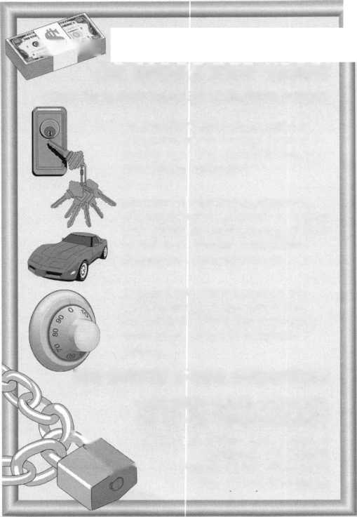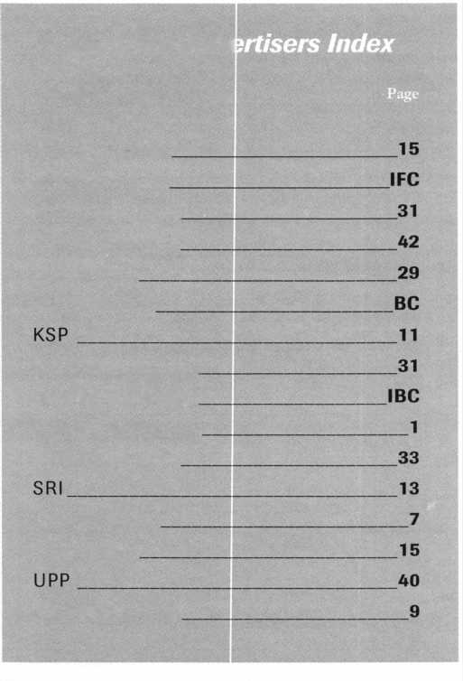

Scholarships are awarded to those individuals who demonstrate their financial need and their desire for more education in the locksmithing field. If you or someone you know fits the above criteria, please fill out the application on this page and send or fax to the ALOA Office at 3003 Live Oak St., Dallas, Texas 75204 by the due date on April 1, 2000. The fax number is (214) 827-1810. Don’t forget to include your letter stating your reason for applying, your three letters of reference and your financial information. No late or incomplete applications will be considered.

ALOA SCHOLARSHIP FOUNDATION, INC.

ALOA/SAVTA SCHOLARSHIP APPLICATION  
3003 Live Oak Street; Dallas TX 75204; (214) 827-1701

Please print or type

NAME PRP LEVEL ALOA/SAVTA #

HOME ADDRESS CITY STATE ZIP

HOME PHONE- DOB // EDUCATIONAL LEVEL [YEARS1 DEGREE, IF ANY.

PRESENT EMPLOYER WORK PHONE- FAX

WORK ADDRESS CITY STATE ZIP POSITION □ FULL TIME □ PART TIME TAKE HOME PAY $

LENGTH OF TIME IN LOCKSMITHING OWNER/SUPERVISOR’S FULL NAME MEMBERSHIP IN TRADE ASSOCIATIONS (LIST BY NAME)

MARITAL STATUS SPOUSE’S OCCUPATION SPOUSE’S TAKE HOME PAY $

COMBINED HOUSEHOLD ADJUSTED GROSS INCOME $ NUMBER OF DEPENDENTS

CLASSES DESIRED DATE OF CLASSES //

ORGANIZATION SPONSORING CLASSES: □ ALOA □ SAVTA □ OTHER (PLEASE NAME)

LO C ATI 0 N

ALOA Scholarships are granted to selected individuals desirous of entering the locksmithing field or to selected individuals already in the locksmithing field who wish to improve their professional skills through education.

Applications for classes being taken locally must be received a minimum of 60 days prior to the date of the class, and will be reviewed as they are submitted. Scholarships for classes at the ALOA or SAVTA convention will be awarded each year at the ALOA Scholarship Foundation meeting preceding the convention and must be received by April 1 each year.

Please attach to this form a letter stating your reason for applying for a scholarship, what you plan to do with the knowledge you obtain and any other information you feel may be helpful to the scholarship board in making its decision. In addition, attach three let­ters of reference from individuals who have personal knowledge of your background and character. The letters should contain their names, addresses and phone numbers. It would be helpful if at least one of these references is an ALOA or SAVTA member. Also, please provide a copy of your most recent tax return.

All scholarship recipients will be required to provide a 3x5 inch photograph of themselves.

APPLICATION CHECK LIST

Only complete applications will be considered for scholarships. An application is considered incomplete unless ALL of the above requested information is received before the deadline: 60 days prior to the date of a class or April 1 for ALOA/SAVTA convention classes. Please send this application after checking off each of the below.

* I have filled in each blank on this form.
* I have written and enclosed a letter explaining my reason for applying.
* I have enclosed three letters of reference.
* I have enclosed a copy of my most recent tax return.
* I am submitting this in time to be received 60 days prior to the date of a class or by April 1 for ALOA/SAVTA convention classes.

CERTIFICATION OF APPLICANT:

I certify that the information contained herein, and all supplemental forms are complete and correct to the best of my knowledge. I further certify that if I am selected as a scholarship recipient I will use the knowledge gained for the improvement, development and advancement of the locksmithing profession.

Signature

Date/

October 1999

/

08/99

Keynotes

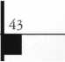

iiiiiii!

Page

'rofessional

Locksmith

Day!

South Carolina locksmiths have something to cheer about. This month features the states very first

Professional Locksmith Day!

Thanks to the determination of the South Carolina Locksmith Association and its president, Lee Griggs, locksmiths around the state will receive their due recognition on October 30,1999.

Ail it took was a letter from Lee to South Carolina Governor Jim Hodges to make this momentous occasion possible. Hats off to SCLA and Lee Griggs for their persistence and their pride in locksmithing!

At right is a copy of the official proclamation signed by Governor Hodges.

vimmo-v ’Sfim

WHEREAS, locks, deadbolts and other locking devices used to safeguard homes, businesses, and

vehicles are installed, modified and repaired by trained, professional locksmiths; and WHEREAS, as security specialists dealing with high-security keying systems, electronic access control

systems, computerized systems, automobile anti-theft ignition systems, state building codes, life safety codes and the ADA for disabled persons, professional locksmiths help ensure the safety and continued well-being of the citizens ofthe Palmetto State; and WHEREAS, withmembersfromSouthCarolina,NorthCarolina, Tennessee, Georgia, and Virginia, the

South Carolina Locksmith Association is anon-profit educational organization dedicated to enhancing professionalism, education and ethics among locksmiths and those in related sectors of the security industry'; and

WHEREAS, the members ofthe South Carolina Locksmith Association are highly quali fied security

professionals engaged in consulting, sales, installation and maintenance oflocks, keys, safes, premises security, access controls, alarms, and other security related endeavors; and WHEREAS, inrecognitionofProfessional Locksmiths Day, the South Carolina Locksmith Association

will provide speakers to promote the locksmith profession to high school seniors and technical school graduates throughout the Palmetto State.

NOW', THEREFORE, I, Jim Hodges, Governor ofthe Great Stateof SouthCarolina, do hereby proclaim October, 30,1999, as

PROFESSIONAL LOCKSMITHS DAY

throughout the state and encourage all South Carolinians to recognize the positive impact of professional locksmiths on the continued security ofthe citizens ofthe Palmetto State.



Jim Hodges  
Governor

State of South Carolina

Keynotes

October 1999



eBSnv

Please

extend my subscription to Locksmith Ledger International

**the Security Professional**

" OPENING A WORLD OP OPPORTUNITIL5

riTIJ **74**

□ 3 YEARS (includes 36 issues, 3 FREE Annual Directory* issues)

USA $90.00

J 2 YEARS (includes 24 issues, 2 FREE Annual Directory* issues)

— USA $64.00 Canada $93.00 International (air) $185.00

.International (surface) $119.00

J 1 YEAR (includes 12 issues, 1 FREE Annual Directory* issue)

USA $41.00 Canada $52.00 International (air) $100.00 International (surface) $65.00

’Comprehensive guide to industry manufacturers, distributors, products and services.

**CARD INVALID UNLESS COMPLETE DATA IS GIVEN**

You must indicate your locksmithing affiliation below:

1. Are you a locksmith or an individual involved in locksmithing? Qyes Qno
2. Your position is: QOwner/Pres. Q3 Employee Q6 Student Q9 Other (specify)

3 Business classification (check one only): a □Locksmith Shop b □Hardware c Q Wholesaler/Distributor d Q Manufacturer e Q Security or Maintenance

1. □ Consultant 3 Q Industrial 5Q Government
2. □ Commercial 4 Q Institutional 6 Q Police

g Q Architect/Specifier z Q Other (specify)

4. Are you involved in purchasing or influencing the purchase of locksmith products?

□yes Qno

Send payment to: Locksmith Publishing Corp. • 850 Busse Hwy. • Park Ridge, IL 60068 • Phone:(847)692-5940 • Fax (847) 692-4604 • Website: [www.lpc.simon-net.com](http://www.lpc.simon-net.com)

Name:_

Company:. Address: _

City:.

. State:.

_Zip:_

Phone:.

.Fax: _

Payment (US FUNDS ONLY): □Money order □Charge Card QCheck#:

Complete For Charge Orders Only: QVISA QMaster Card □American Express

Account # :Exp. Date:

Signature:

IM9

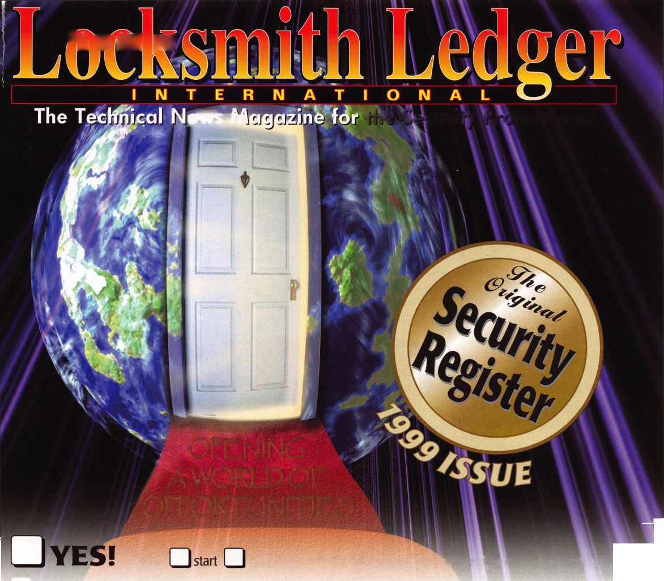

MAZ24-N-PMT

Mazda

DA31-N-PHT

**without**

or

Nissan Maxima Infiniti 130

Now you can duplicate electronic transponder keys without your customer bringing in  
their car or the original key. Store the codes in your database for future use.

It’s convenient, fast and profitable.

It’s another JET innovation.

ET ETD - DUPLICATOR aftware for Windows 95/98 conveniently provided on CD-ROM

JET HARDWARE MANUFACTURING CORP

800 HINSDALE STREET, BROOKLYN, NY

**Locksmiths...**

**duplicgjt**

e

Audi

Porsche

Volkswagen

Buick Park Avenue Chevy Venture Olds Silhouette Pontiac Montana Primary

0

Cadillac Seville Primary

hpim-n-phi

Honda Acura

_ TiQHFsmim

Cadillac Catera

